Wader Management Plan

CASE TITLE:
(this is the title of your 2021 AECS application)

BRN:

MLC:

DATE OF PLAN:

This template is to be used for the following annual management options:
• Wader Grazed grassland
• Wader & Wildlife Mown Grassland

Please ensure you meet the option requirements and supporting guidance before completing this plan.

Section 1: Continuity
Does this plan continue management for waders delivered from an expiring 2015 or 2016 prefixed AECS contract?
Please tick one of the boxes
Yes – continuation of contract
If Yes, please enter the contract reference number here:

No - (no previous AECS contract containing wader management)

No - (previous AECS contract for wader management ended in 2020 and I did not accept the offer of a 1-year extension)

Section 2: Collaboration
Please state the BRN or AECS contract reference numbers for all collaborating businesses you are working with to deliver for waders. Each collaborator must:
- Hold an active AECS contract from the 2017, 2018 or 2019 application round or be a new or returning applicant to AECS in 2021.
- and the locations involved must be within 5km of your holding at the nearest point as the wader flies.

Section 3: Vulnerable Priority Species
Please indicate which species below are present on your holding during their breeding season and will benefit from AECS management. Your wader project officer should confirm this information is correct. Alternatively, you can supply evidence from recent BTO records (within 5 years) alongside your application.

Curlew
Lapwing
Redshank
Snipe
Oystercatcher

Project Officer Name:
Project Name:

Project Officer Comments on VPS

Section 4: Wader Grazed grassland
For every field being entered into Wader Grazed grassland management, please provide the following information, based on the example below. Add as many tables as you require.

YOU MUST COPY A PHOTOGRAPH OF EACH FIELD INTO THIS DOCUMENT WHICH MUST BE CLEARLY LABELLED WITH THE FIELD PARCEL CODE.

Example
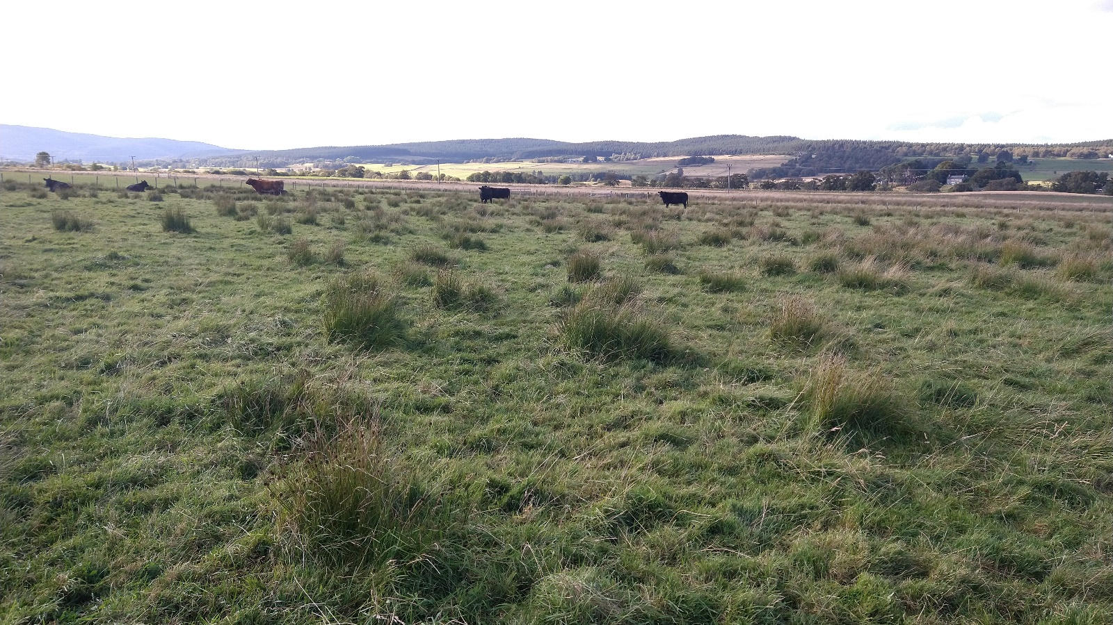
Field: NX/123213/123123 Photo credit Paul Chapman, SAC Consulting

Field Parcel Identifier and size | NX/123213/123123 4.5ha
Brief description of habitat within the field (e.g. rush cover, wetland areas, boundary features etc.) | Open aspect field with no surrounding woodland or hedge features within 30m.  Soft rush scattered across the field with a few dense areas. Field periodically floods during the year.
Proposed grazing regime to be adopted | Livestock will be excluded from 1 April to 12 May, followed by a period of light grazing with cattle
Capital work proposed | Two wader scrapes and 1ha of rush cutting within the dense area of rush will be undertaken as shown on the management map.

Field Parcel Identifier and size
Brief description of habitat within the field (e.g. rush cover, wetland areas, boundary features etc.)
Proposed grazing regime to be adopted
Capital work proposed

Field Parcel Identifier and size
Brief description of habitat within the field (e.g. rush cover, wetland areas, boundary features etc.)
Proposed grazing regime to be adopted
Capital work proposed

Field Parcel Identifier and size
Brief description of habitat within the field (e.g. rush cover, wetland areas, boundary features etc.)
Proposed grazing regime to be adopted
Capital work proposed

Section 5: Wader and Wildlife Mown Grassland
For every field being entered into Wader and Wildlife Mown grassland management, please provide the following information, based on the example below. Add as many tables as you require.
YOU MUST COPY A PHOTOGRAPH OF EACH FIELD INTO THIS DOCUMENT WHICH MUST BE CLEARLY LABELLED WITH THE FIELD PARCEL CODE.

Example

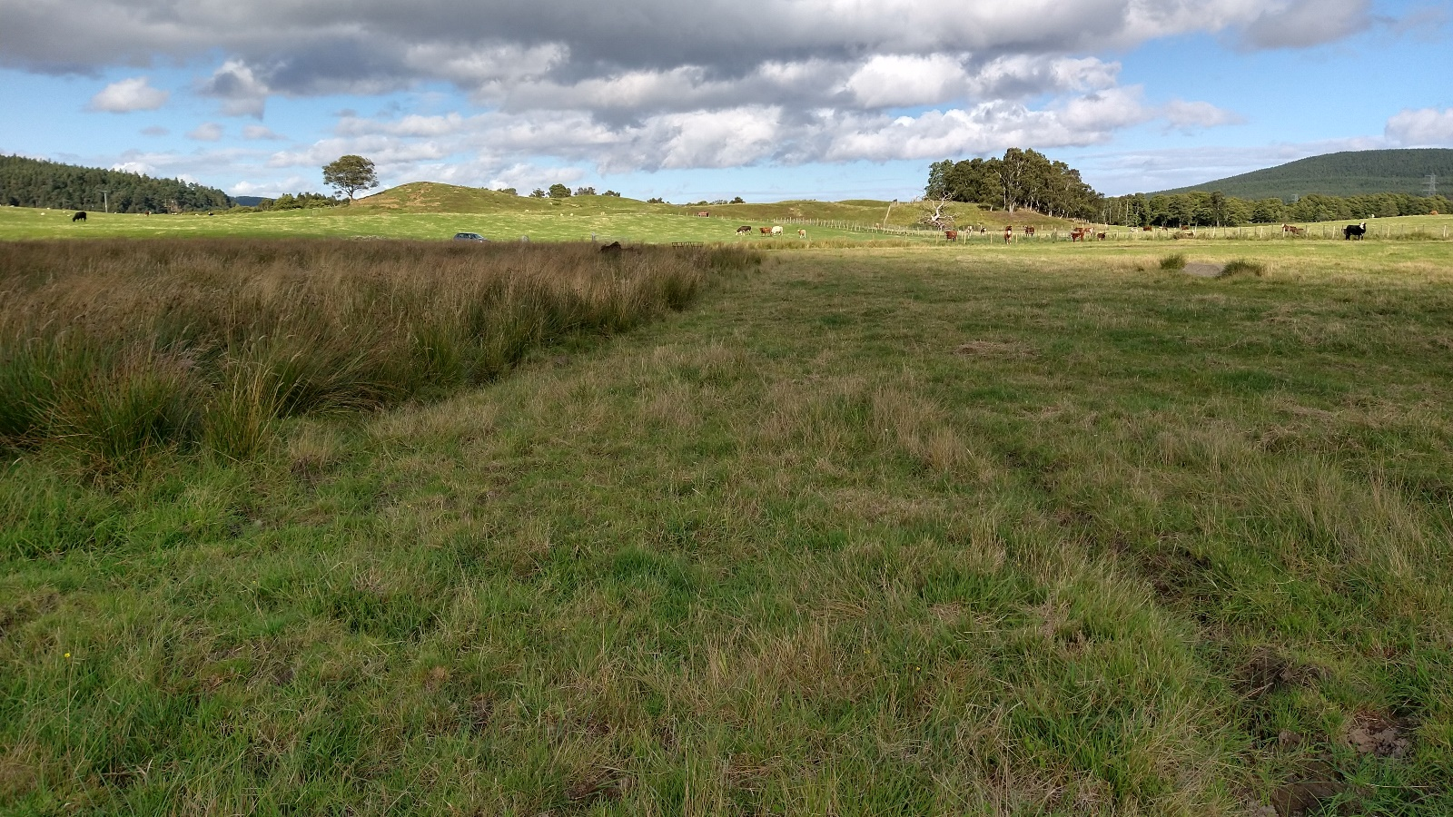
NX/123456/123456 Photo credit Paul Chapman, SAC Consulting

Field Parcel Identifier and size | NX/123456/123456 7ha
Brief description of the field which must include boundary features | Field taken for late cut silage.  Field is fenced with a small copse of trees adjacent to the NE corner
Capital work proposed | N/A

Field Parcel Identifier and size
Brief description of the field which must include boundary features
Capital work proposed

Field Parcel Identifier and size
Brief description of the field which must include boundary features
Capital work proposed

Project Officer Comments on wader management plan:

