Moorland Management and Grazing Plan 2018

This document provides a template to use for your moorland management and grazing plan. It also contains guidance for each section. You may wish to delete the guidance to use the template.

Please complete all sections and provide all information and photographs/maps etc. requested. If any sections are not relevant to your plan, please mark as n/a, but do not delete the section. If you are applying for deer control only, you do not need to complete the grazing management section.

CASE TITLE: A Farm Environment Plan for Lark Farm

BRN: 654321

DATE OF PLAN & SURVEY: 2nd March 2018;
Field Surveys: 24th-26th January 2018, 30th January 2018, 21st February 2018 (Total = 5 days)
The plan was completed by A N Ecologist, MSc MCIEEM, and A N Farm Environment Advisor C.Env. MCIEEM

Section 1 – General site information

1.1 Details of site where moorland management will take place

The moorland management will take place on two units, namely Lark Farm MLC 000/1111 and Merlin Farm SLC 000/2222 The overall moorland extends to 1571.43ha. It is situated within the Southern Uplands, with Lark Farm sitting within Dumfries & Galloway, whilst Merlin Farm lies within South Lanarkshire.
Lark Farm is sited on the land and hills immediately west of Settlement, on the north side of the Trout Water, which flows into the River Salmon, and further west on West Hill (south of the Trout Water). The moorland rises from 239m in the Trout Water Glen to 522m in the west at Harrow Hill.
Merlin Farm sits on the west side of the Dipper Water and south-west of the Dipper Reservoir. It takes in several hills, including Newton Law and part of Hilly Hill, with part of the unit sitting within the Hilly Hills Site of Special Scientific Interest (SSSI), and rises from 400m to 688m at Newton Law.
The moorland is managed in two main units:
Table 1 Moorland Parcels

Map Ref | Unit Name | Total Ha | Main Moorland Parcel | Ha Open Moorland
MM01 | Lark Farm – Green Hill & Black Moor | 700.35ha | NA/11111/11111 | 700.35ha
MM02 | Hilly Hill & Newton Law | 871.08ha | NA/22222/22222 | 871.08ha
Total |  | 1571.43ha |  | 1571.43ha

Lark Farm (Map 01), covers Green Hill and Black Moor, MM01, and covers land on either side of the Trout Water. Green Hill is situated to the south of the Trout Water and takes in Green Hill itself (516m), Harrow Hill (522m) and parts of How Knowe (529m) and Big Rig. Black Moor is situated to the north of the Trout Water. It covers the rectangular strip of moorland located between Lark Plantation to the east and Shawe Bank to the west, and Hillhead Muir to the north, with its southern boundary following much of the Trout Water.
Hilly Hill and Newton Law MM02 (Map 02) is situated to the west of the Dipper Water and Dipper Reservoir, and takes in several summits and their upland slopes, including Newton Law (688m), as well as Plover Dod, Blaeberry Brae, the southern side of Lamb Law and Hogg Hill further to the south and east of the Hilly Hill summit itself. The Hogg Hill part of the Hilly Hill unit is the only part that sits within the boundaries of the Hilly Hill SSSI.
The Lark Farm unit is made-up of two large parcels of open moorland (Green Hill and Black Moor), whilst the Hilly Hill unit covers one main parcel, centred on Newton Law. Both areas have associated ‘in-bye’ land.
The Hilly Hill SSSI designated features are:
Upland habitats: Upland assemblage (Favourable Maintained).

The Hilly Hill SSSI supports an assemblage of upland vegetation communities representative of the Southern Uplands, including blanket bog, subalpine dry dwarf-shrub heath, and calcareous types of spring-head, rill and flush.
1.2 Details of land condition
All units were visited by A N Ecologist, to assess their current condition and management needs. This field check was guided by the Joint Nature Conservation Committee’s (JNCC) Common Standards Monitoring Guidance for Upland habitats (Version October 2006) and was also informed by the surveyor’s extensive experience of working in the uplands. Whilst the survey period was outwith the main growth season, with the likelihood that not all species were evident, it was still considered sufficient to give an accurate assessment of the current condition of the vegetation. In addition, with specific regard to Hilly Hill SSSI, A N Ecologist also consulted with SNH to obtain all available Site Condition Monitoring (SCM) information and to also obtain their views on management. For Hilly Hill, the assessment also refered to exisitng National Vegetation Classification (NVC) survey data published by SNH.
MM01: Lark Farm
‘Green Hill’: The bulk of this area is largely divided between species-poor acid grassland, species-poor Purple Moor-grass (Molinia caerulea)-dominated marshy grassland, and more diverse blanket bog (& wet modified bog), with a number of streams heading down from summit areas towards lower fields and the Trout Water to the north.
The summits are largely dominated by a mosaic of species-poor grasslands, dominated by species such as Nardus stricta (Mat-grass) and Juncus squarrosus (Heath Rush), with no/little ericoid species, and generally species-poor blanket bog/mire communities, typically with cotton grasses (Eriophorum spp), thick layers of mosses (Polytrichum spp, Hylocomium splendens, Rhytidiadelphus squarrosus & R. loreus) and Sphagnum moss species, with S. capillifolium (subsp rubellum) being the most frequent.

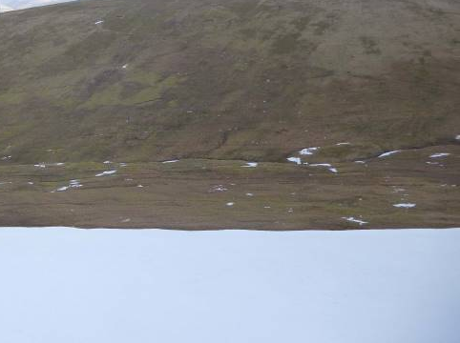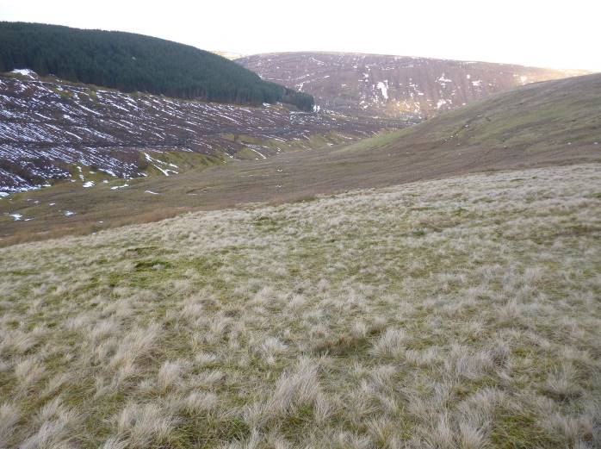
Figure 1: Green Hill grasslands: mosaic of grassland communities, including Nardus-dominated, Juncus-squarrosus-dominated, Molinia-dominated and more improved ‘green’ patches.

The slopes are dominated by drier grasslands with Nardus stricta (Mat-grass) abundant in many areas, although more enriched (greener), improved grassland areas are occasionally dotted amongst this area. These areas often become intermixed with Molinia-dominated marshier grassland (probably relict wet modified bog in places), with occasional marshy Juncus-dominated patches, and wetter mire communities with much Sphagnum and Polytrichum moss species, as the slopes bottom out at the bottom of the glens, or in blocked ditches.

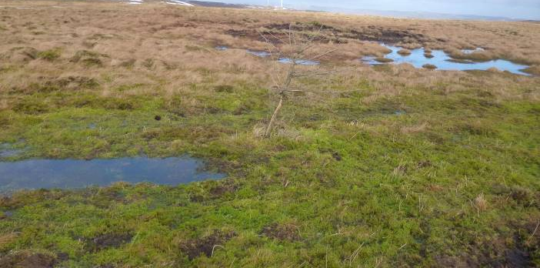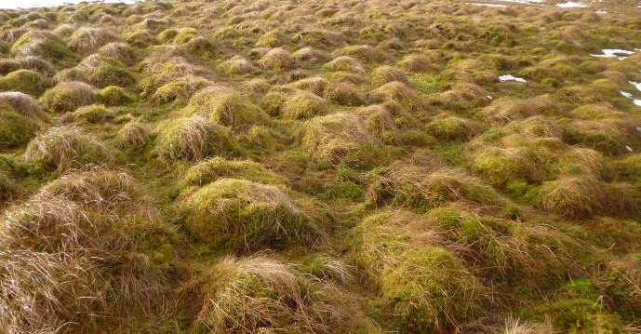
Figure 2: Green Hill: Mire/Bog communities around How Knowe part of site. Note Sphagnum-moss dominated pools and Cotton-grass/moss hummocks in places.

There are some key areas which do have more diverse modified bog communities, most notably at the southern end of the summits by How Knowe. Here, Sphagnum mosses such as Sphagnum papillosum and S. palustre were found in addition to two or three other Sphagnum species, as well as Cross-leaved Heath (Erica tetralix), some Ling (Calluna vulgaris), Cotton-grass and Deer-grass and wetter bog pools. It was also here that grouse droppings were noted, whilst a snipe was spotted nearby.

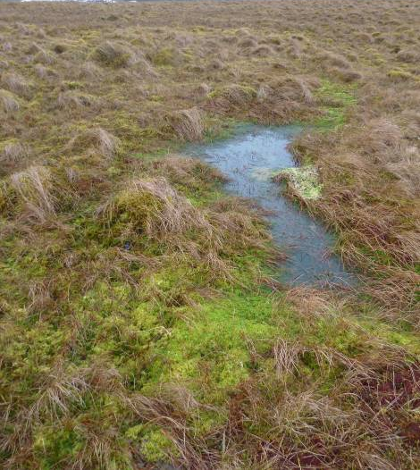
Figure 3: Green Hill: Harrow Hill: Typical blanket bog community on summit area

Overall, the Green Hill area is showing the effects of many decades of overgrazing and drainage, with little heather present and no bilberry (Vaccinium myrtillus) spotted, although it is likely the odd plant is present in the area. However, the presence of some bog/mire communities on the summit areas, albeit modified and also exhibiting the effects of overgrazing, does give this area some value, and any management which gives this area ‘a rest’ will likely see these areas recover favourably in time, especially if combined with some drain-blocking in places in the future.

‘Black Moor’ : This area is broadly divided between the heavily overgrazed southern areas lying below (south of) the new -related track, lying approximately 100m north of the main Trout Water road, and the less grazed, more heather-dominated areas to the north of the road.
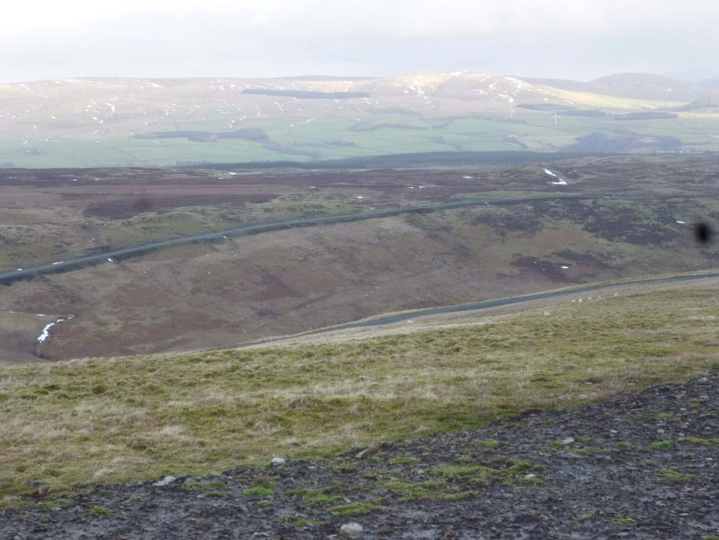
Figure 4: Black Moor from Green Hill: Note track halfway up slope & patchy heather/improved grassland below track, with improved grassland beside (and north of) track, as well as large expanse of wet modified bog.

The moorland to the south of the road has been and continues to be heavily grazed by sheep, mainly due to its more sheltered location (cf. Black Moor itself), but also because of the bigger area of improved Agrostis-grassland present, which represents the best grazing in the area. This moorland is largely considered to be a mosaic of dry heath and acid grassland (much of it semi-improved and species-poor), marshy grassland and bracken (both scattered and in more uniform patches). The dry heath communities include common overgrazed, patchy topiary-like Ling (Calluna vulgaris) and frequent flowering Bell Heather (Erica cinerea), alongside the sheep-favoured grassland within a mosaic of wetter Molinia- and Juncus (rush)-dominated marshy grassland patches. These areas blend into more wooded areas (some already fenced off from livestock), with some scattered scrub.

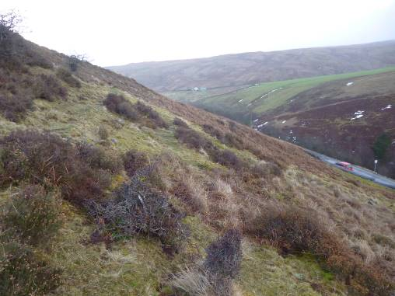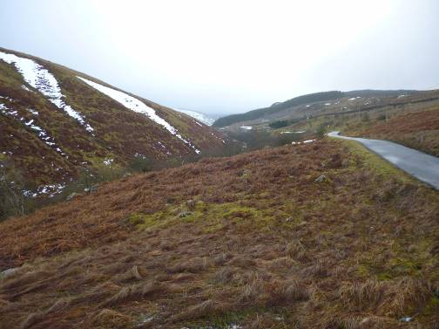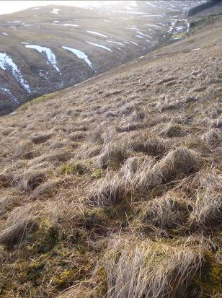
Figure 5: Land below (south) of track; Note overgrazing, bracken and Molinia/Juncus-dominated marshy grassland

The moorland to the north of the track is in much better condition overall, except for areas beside the improved grassland directly north of the track; the latter area supporting a largely similar habitat to that south of the track. The main moorland area has clearly benefitted from less heavy sheep grazing pressure. In this larger section, there are large areas of healthy-looking heather-dominated blanket mire vegetation, growing on peat (probably greater than 50cm deep), typically with abundant flowering Ling (Calluna vulgaris), Eriophorum angustifolium (Cotton-grass), Cross-leaved Heath (Erica tetralix), wetter Sphagnum moss spp, Crowberry (Empetrum nigrum), Bilberry (Vaccinium myrtillus), Bog Asphodel (Narthecium ossifragum) , frequent Purple Moor-grass Molinia grass, as well as common mosses such as Polytrichum spp,, Pleurozium schreberi, etc.
In these areas, between 30-50% of Bilberry shoots had been grazed, with this figure going up to 80% close to Shawe Bank forestry and adjacent more-improved/dry heath grazing areas, where animals would naturally concentrate due to the better grazing. The heather looked in a healthy state in many places, with some young regrowth in places. Due to the presence of peat, some of which appeared to be deeper than 50cm, no burning is advisable on this area in the future.

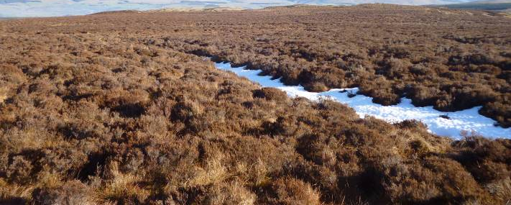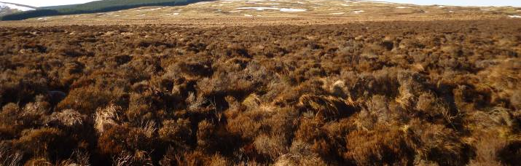
Figure 6: Heather-dominated wet modified bog on Black Moor, with a favourable species diversity

In addition, there were a number of Molinia-dominated and Juncus-dominated wetter areas, classed as marshy grassland here, although on flatter areas growing on deeper peat, it is likely the Molinia-grassland area also represents the remnants of blanket bog way in the past, having suffered massive modification due to decades of heavy grazing and drainage. However, throughout this moorland area, there was a mosaic of other habitats, including the odd Sphagnum-dominated deeper blanket bog area, wet heath, occasional patches of Nardus stricta (Mat-grass) species-poor acid grassland, blending into more improved Agrostis grassland with topiary heather plants present on drier areas/knowes. However, such signs of overgrazing were localised and adjacent to the improved grassland areas only, where sheep would naturally congregate more due to better quality grazing.

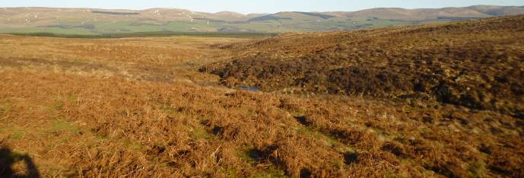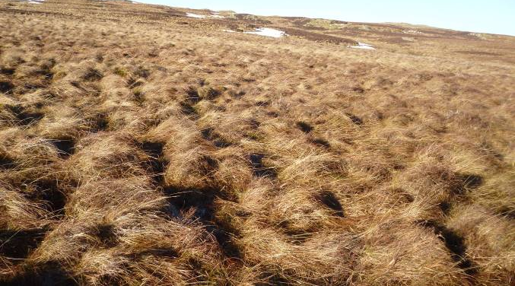
Figure 7: Large areas of Molinia-dominated vegetation mix with heath-like areas, whilst scattered Bracken present on drier slopes: Note improved grassland beneath Bracken.

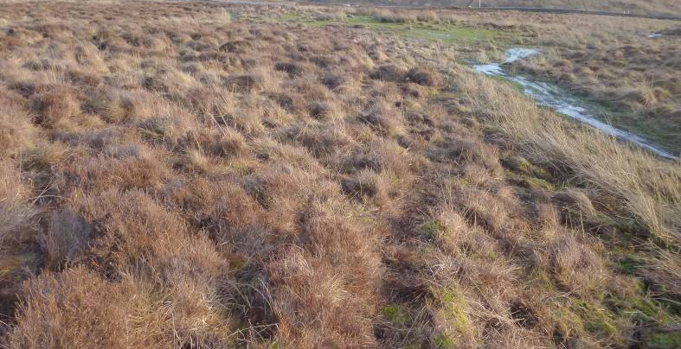
Figure 8: Localised Sphagnum-moss-dominated blanket bog at edge of Black Moor

There is some Bracken present on Black Moor, on better-drained areas, however, most of this had improved grassland underneath and visible, this still being of value to livestock.

Therefore, the vegetation on the Green Hill section and southern section of Black Moor are currently in poor overall condition, due to overgrazing, whilst the upper wetter areas of Black Moor are in reasonably favourable condition. Map 03 shows habitat condition for MM01.

All would benefit from reduced grazing, as well as bracken control and no muirburn, where relevant.

In terms of birdlife, consultation with RSPB confired Black Moor is within 1km of two known black grouse lek sites, both to the north and south. The presence of abundant heather, bilberry, crowberry and cotton-grass, as well as dry and wet patches, does make the vegetation, especially on the main Black Moor area, good habitat for black grouse feeding (3 red grouse were spotted in this area during the survey), whilst the adjacent native woodland by the Trout Water also provides good habitat for the species. It is also likely that this area will be used by other species, such as Golden Plover and Curlew, as well as Snipe (spotted on Green Hill).

MM02: Hilly Hill (and Newton Law)

This area is largely divided by the Otter Burn, which cuts between the larger Newton Law section of this unit to the north and the smaller Hilly Hill SSSI part, dominated by Hogg Hill. However, the vegetation is similar throughout the unit.

Much of the unit is divided up into mosaics of Molinia (Purple Moor-grass)-dominated mire (classified here as marshy grassland but potentially wet extremely-modified bog in places where peat is greater than 50cm), largely species-poor Nardus-grassland, Juncus squarrosus-dominated and more improved Agrostis-grasslands, with degraded blanket bog/mire habitats present on areas of deeper peat. In some parts, there is more dry heath-like vegetation present as well as patches of Great Wood-rush (Luzula sylvatica) and ferns, with very occasional more basic vegetation present.

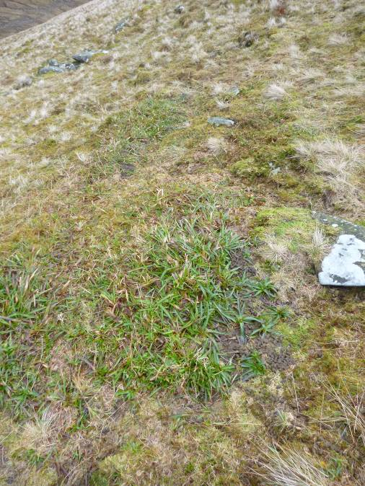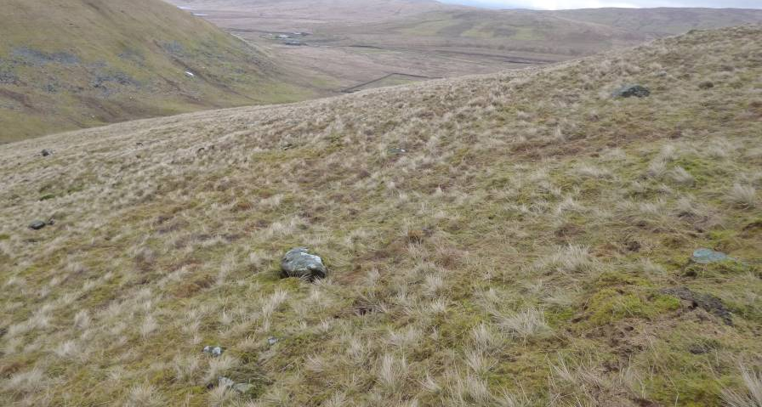
Figure 9: Hogg Hill acid Nardus-grassland, showing localised overgrazing of Luzula sylvatica (Great Wood-rush).

The majority of the unit north of the Otter Burn is heavily grazed and appears to have been so for decades, with very species-poor Nardus- and Molinia-patches dominating over large areas. To the south of the burn, the vegetation also looks overgrazed in places, but is showing signs of less strong grazing pressure than to the north, having a little more evident Bilberry (Vaccinium myrtillus), for example, as well as Heath Bedstraw (Galium saxatile), Tormentil (Potentilla erecta) and Hard Fern (Blechnum spicant). Nevertheless, overgrazing was still clearly evident in the south, especially towards the bottom of the burn and nearest to the sheep fanks (within the SSSI), where Bilberry had 80% of shoots grazed and virtually prostrate Ling (Calluna vulgaris) and Great Wood-rush (Luzula sylvatica) was present.

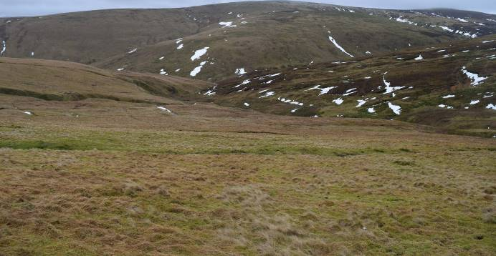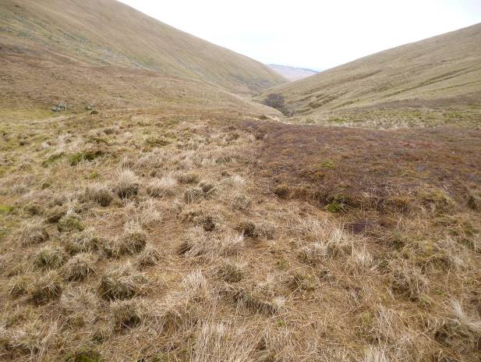
Figure 10: Newton Law lower slopes looking south towards Hilly Hill, with heavily overgrazed Ling heather at Otter Burn.

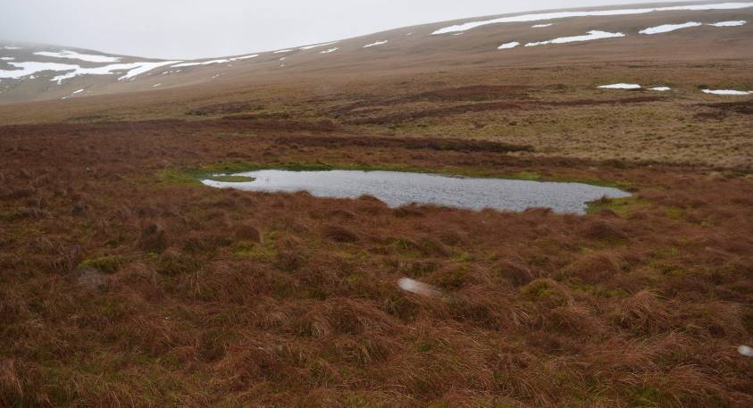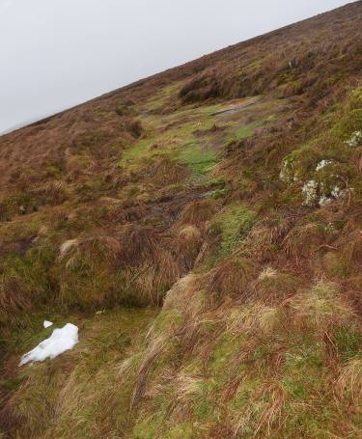
Figure 11: Plover Dod: Note pool with Sphagnum moss species and one of drains from bog.

The mire/bog communities to the north of the burn do, however, still retain some interest, even where there is serious hagging, especially north-west of Newton Law. In this area, Sphagnum papillosum and other Sphagnum species are still present, along with other mire vegetation, and would benefit from a break in winter grazing in particular, and grazing in general. Other bog/mire areas, most notably Plover Dod, also had good blanket bog/mire vegetation present, including pools at Plover Dod, and again would benefit from a rest from overgrazing, as well as local drain blocking.

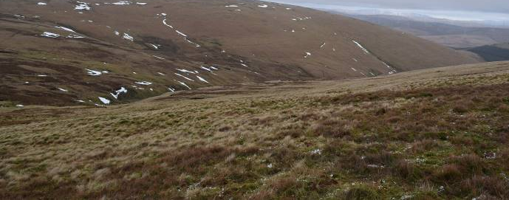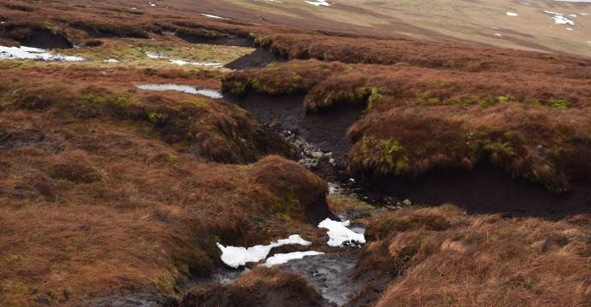
Figure 12: Looking north from Newton Law & peat hags at Newton Law, with mire vegetation growth on the top and edge of area

The presence of a flock of over 20 Golden Plover and over 15 Red Grouse, together with over 7 mountain hares on adjacent mire communities with less current grazing, at the top of the Otter Burn, demonstrates what other species would benefit from these mire habitats being brought into better condition.

The current condition of the Hilly Hill SSSI is considered to be ‘Favourable maintained’. However, this assessment, in large part, relates to the relatively good condition of the area of SSSI land outwith this unit, where grazing pressure has been significanrtly reduced in agreement with SNH, and also visited by the surveyor for comparison purposes. The higher land to the south of Otter Burn, for example, had many indicators of better condition, including abundant Cloudberry (Rubus chamaemorus), Bilberry (often with approx 20-30% of shoots grazed away from more improved grassland areas, where grazing did reach approx 80% of shoots), healthier-looking heather and more Sphagnum spp, including more Sphagnum papillosum, a good indicator of good bog health.

The field surveys concured with the view of SNH in July 2011 and also more recently in 2018, that the vegetation within the Hogg Hill heft would still benefit from reduced grazing pressure overall, and especially with significant reductions in winter browsing/grazing, with SNH (July 2011) stating ‘The evidence suggests that an absence of, or at least significant reduction in, winter grazing pressure will be required in the Hogg Hill heft if similar habitat benefits to those seen south of the fence are to take place’. From observations during this recent field assessment, this conclusion is still relevant, and could be applied across the entire Hilly Hill unit, including Newton Law, although as stated, the Hogg Hill area was in better condition than the rest of the unit due to recent agreements in management with SNH. However, it is also considered that some summer grazing will still be required in order to ensure that shorter grassland areas are kept open for any wader bird species, such as Golden Plover, as well as ensuring that some grass species do not become too dominant. It is considered that the mire habitats and more species-rich grassland communities will greatly improve their condition under such a management regime.

Consultation with RSPB has highlighted Dipper Reservoir as a historical site for black grouse, and, although there is no current monitoring, it is likely to still be an important site for them.

Therefore, overall, the Hilly Hill unit is currently overgrazed and in a generally poor condition as a result of this situation, albeit the land within the SSSI section (Hogg Hill) is in better condition than the land to the north of the Otter Burn. Map 04 shows habitat condition for MM02.

Table 1 Main Habitat Types and Extent
Lark Farm – Map 01
LPID | Map Ref |  | Broad Habitat |  | Habitat |  | Ha |  | Percent
NA/11111/11111 | MM01 |  | Grassland |  | Acid grassland - unimproved |  | 202.41 |  | 28.90%
NA/11111/11111 | MM01 |  | Mire |  | Wet modified bog |  | 202.33 |  | 28.89%
NA/11111/11111 | MM01 |  | Grassland |  | Marsh/marshy grassland |  | 190.08 |  | 27.14%
NA/11111/11111 | MM01 |  | Heathland |  | Dry heath/acid grassland mosaic |  | 53.25 |  | 7.60%
NA/11111/11111 | MM01 |  | Heathland |  | Wet heath/acid grassland mosaic |  | 22.71 |  | 3.24%
NA/11111/11111 | MM01 |  | Grassland |  | Acid Grassland / Marshy grassland |  | 13.73 |  | 1.96%
NA/11111/11111 | MM01 |  | Woodland |  | Broadleaved woodland - semi-natural |  | 9.49 |  | 1.36%
NA/11111/11111 | MM01 |  | Mire |  | Blanket sphagnum bog |  | 5.41 |  | 0.77%
NA/11111/11111 | MM01 |  | Heathland |  | Wet dwarf shrub heath |  | 0.92 |  | 0.13%
 |  |  |  |  |  |  | 700.35 |  | 100%

Hilly Hill – Map 02
LPID | Map Ref | Broad Habitat | Habitat | Ha | Percent
NA/22222/22222 | MM02 | Mire | Blanket sphagnum bog | 339.70 | 39.00%
NA/22222/22222 | MM02 | Grassland | Acid grassland - unimproved | 186.80 | 21.45%
NA/22222/22222 | MM02 | Grassland | Marsh/marshy grassland | 145.52 | 16.71%
NA/22222/22222 | MM02 | Mire | Wet modified bog | 102.75 | 11.80%
NA/22222/22222 | MM02 | Mire | Blanket bog/Acid grassland | 85.04 | 9.76%
NA/22222/22222 | MM02 | Heathland | Dry heath/acid grassland mosaic | 7.20 | 0.83%
NA/22222/22222 | MM02 | Heathland | Dry dwarf shrub heath - acid | 1.74 | 0.20%
NA/22222/22222 | MM02 | Heathland | Wet heath/acid grassland mosaic | 0.95 | 0.11%
NA/22222/22222 | MM02 | Tall herb and fern | Other tall herb and fern - non ruderal | 0.66 | 0.08%
NA/22222/22222 | MM02 | Open water | Running water | 0.47 | 0.05%
NA/22222/22222 | MM02 | Mire | Flush and spring - basic flush | 0.16 | 0.02%
NA/22222/22222 | MM02 | Mire | Brophyte-dominated spring | 0.07 | 0.01%
NA/22222/22222 | MM02 | Open water | Standing water | 0.03 | 0.00%
 |  |  |  | 871.08 | 100%

Table 2 Habitat Condition
Lark Farm –
Map 03
LPID | Map Ref |  | Broad Habitat |  | Condition | Ha |  | Percent
NA/11111/11111 | MM01 |  | Grassland |  | Over-grazed grassland | 378.86 |  | 54.10%
NA/11111/11111 | MM01 |  | Grassland |  | Recovering grassland | 27.37 |  | 3.91%
NA/11111/11111 | MM01 |  | Heathland |  | Supressed heathland | 76.87 |  | 10.98%
NA/11111/11111 | MM01 |  | Mire |  | Recovering mire | 162.75 |  | 23.24%
NA/11111/11111 | MM01 |  | Mire |  | Unfavourable mire/bog | 44.43 |  | 6.34%
NA/11111/11111 | MM01 |  | Mire |  | Favourable mire | 0.58 |  | 0.08%
NA/11111/11111 | MM01 |  | Woodland |  | Other (woodland/scrub) | 9.49 |  | 1.36%
 |  |  |  |  |  | 700.35 |  | 100%
Hilly Hill – Map 04
LPID | Map Ref |  | Broad Habitat |  | Condition | Ha |  | Percent
NA/22222/22222 | MM02 |  | Grassland |  | Over-grazed grassland | 326.77 |  | 37.51%
NA/22222/22222 | MM02 |  | Heathland |  | Supressed heathland | 8.13 |  | 0.62%
NA/22222/22222 | MM02 |  | Heathland |  | Recovering heathland | 0.81 |  | 0.09%
NA/22222/22222 | MM02 |  | Mire |  | Unfavourable mire/bog | 534.22 |  | 61.33%
NA/22222/22222 | MM02 |  | Open water |  | Other (open water) | 0.49 |  | 0.06%
NA/22222/22222 | MM02 |  | Tall herb and fern |  | Favourable fern | 0.66 |  | 0.08%
 |  |  |  |  |  | 871.08 |  | 100%

Section 2 – Current and Past Management

2.1 Current management

All units are managed primarily for upland (blackface) sheep production but cows and their calves do graze all holdings between 1st June and 10th October each year. Management is carried out by two full-time shepherds. There is no deer grazing in these areas. All units are subject to supplementary feeding with an estimated 6 tonnes of blocks used annually across all three units. Map 07 shows the distribution of feeding sites, as well as tracks.

None of the management is currently supported by Agri-environment or SNH Management Agreement funding, the latter agreement expiring over 5 years ago.

MM01: Lark Farm - Map 05

Lark Farm ‘Green Hill’

As with many other holdings within the locality, Green Hill is managed primarily for upland sheep production. There is no game management (including no predator control) on the moorland areas. No burning nor bracken control takes place, although both are not applicable to this unit.
There are 3 hefts on Green Hill, with the current flock numbering 445 ewes and 125 hogs (Total = 570 sheep), divided up between Harrow Hill (175 ewes and 49 Hogs) to the west, Green Hill (160 ewes and 45 hogs), and Farfield (110 ewes and 31 hogs) to the east. All hogs are off-wintered from 1st October to 1st April each year, with the ewes coming off the hill for 4 weeks during tupping from 20th November, and again for 4 weeks during lambing period from 15th April each year.
30 cows and 30 calves graze the area from 1st June to 10th October each year, with the same animals also grazing on the Black Moor unit over the same period.
Lark Farm ‘Black Moor’

As with the other holdings, Black Moor is managed mainly for upland sheep production. There is no game management (including no predator control) on the moorland area at this time, and no muirburn, with the last fire being 5 years ago under an earlier RSS scheme. There is also presently no bracken control, with the last aerial spraying application being approximately 15 years ago.
There are 2 hefts on Black Moor, with the current flock numbering 365 ewes and 102 hogs (Total = 467 sheep), divided up between Black Moor (105 ewes and 29 Hogs) to the north, and Roadside (260 ewes and 73 hogs). The Roadside heft is located beside and to the south of the road down to the Trout Water. All hogs are off-wintered from 1st October to 1st April each year, with the ewes coming off the hill for 4 weeks during tupping from 20th November, and again for 4 weeks during lambing period from 15th April each year.
30 cows and 30 calves graze the area from 1st June to 10th October each year, with the same animals also grazing on the Green Hill unit over the same period.
MM02: Hilly Hill (and Newton Law) – Map 06
Hilly Hill (Hogg Hill) and Newton Law are managed mainly for upland sheep production. Management for game primarily involves predator control for grouse. This is carried-out by Cortina Estate, who retain the shooting rights, under a 150 year agreement, and who own and manage the neighbouring land. No muirburn or bracken control takes place on the land nor is it applicable at this time.
There are 7 hefts on Hilly Hill and Newton Law, with the current flock numbering 706 ewes and 198 hogs (Total = 904 sheep), divided up between Hogg Hill (130 ewes and 36 Hogs) and Stanehead (75 ewes and 21 hogs) on the parts of the unit within the Hilly Hill SSSI, to the following on land north of Otter Burn: Otter (45 ewes and 13 hogs), Brae (110 ewes and 31 hogs), Deadside (130 ewes and 36 hogs), Lamb Law (86 ewes and 25 hogs), and Cleuchhead (130 ewes and 36 hogs). All hogs are off-wintered from 1st October to 1st April each year, with the ewes coming off the hill for 4 weeks during tupping from 20th November, and again for 4 weeks during lambing period from 15th April each year.
30 cows and 30 calves graze the area from 1st June to 10th October each year.
2.2 Past management and any previous funding obtained for this management

The management of the moorland has been long-established, primarily for the purposes of upland sheep production (and cows), with the Farmer family having managed the land for over 80 years.
Livestock:
Grazing management practices have broadly remained consistent over the past 80 years, with no reductions in livestock numbers.
Bracken Control
Black Moor only (MM01): Efforts to control bracken have been carried out on the holding in the past, with the most recent activity being aerial spraying approximately 15 years ago on Black Moor. The other areas have not required any bracken control due to the relative absence of bracken to date.
Muirburn
Black Moor only (MM01): Muirburn had been an established practice over Black Moor for many years, with the most recent burns taking place approximately 5 years ago, as part of the last RSS agri-environment scheme for the area (since expired). The scheme required 5ha of moorland be burnt annually. The applicant does not wish to carry out any more muirburn in this area. This is in keeping with the Muirburn Code, as there are peat depths greater than 50cm in this area.
Funding

Black Moor (beyond the in-bye areas): has been managed under agri-environment schemes for at least the past 10 years with 5 years under the under a Rural Stewardship Scheme, followed by a further 5 years under a Rural Priorities Rural Development Contract (Case No. 000000). The RDC included Moorland Management Grazing on 755 ha (which included hill parks); Away Wintering (240 hoggs); and 5ha/year of Heather Burning. This was part of a larger scheme, which included measures on the in-bye, as well as woodland creation. The contract is still in place for the woodland creation until 2025, but finished in 2017 for the farmed areas, including the moorland.

Hilly Hill has been managed under a 10-year Environmentally Sensitive Area (ESA) Scheme, which ended in 2012. This included 12ha/year of heather burning, as well as livestock exclusion on 25 ha of heather.

Section 3 – Management requirements (including grazing management)

3.1 Management required
Describe what management is needed to benefit the moorland habitats and species. This could include (but is not restricted to) the following:
- livestock management
- deer management
- peatland restoration
- muirburn
- bracken management
- predator control
- any other capital items, e.g. fencing

Grazing management requirements should be described in this plan. This section will count as a sub-plan within your moorland management and grazing plan. You must also include sub-plans for other management options / capital items that are relevant to your application and submit them as part of your moorland management and grazing plan – please see the Moorland Management option text on https://www.ruralpayments.org for plan templates. (These can be appended to your moorland management and grazing plan or presented as separate plans.)
There are four main areas of management needed to benefit the moorland habitats and species on the two units:
- MM01 & MM02 - A reduction in livestock grazing pressure, particularly in winter.
- MM01 Black Moor - Bracken control to increase the area of avaiable grazing across the moor
- MM01 & MM02 - Ceasation of burning - No burning should take place on any mire/bog areas on Lark Farm or Hilly Hill as there is still significant peat under such vegetation, often clearly more than 50cm, and often over 1.5m (Hilly Hill: Newton Law, Plover Dod, Blaeberry Brae, etc).
- MM02 – Plover Dod – peatland restoration through ditch-blocking

MM01 Lark Farm:
‘Green Hill’:
Reducing sheep grazing by between 10 and 20% on all hefts, in association with continuation of the current programme of away-wintering of hoggs will give the bog and more species-rich areas an opportunity to recover from past overgrazing.
‘Black Moor’:
Ideally, there should be a total removal of grazing from Black Moor over winter to allow plants, such as the heathers, crowberry, bilberry, and cranberry to set seed and produce fruit for black grouse. Less grazing will also allow the Sphagnum moss and other species to recover from past overgrazing and burning. However, a reduction in winter grazing by 10-20% should see improvements.
There should be no muirburn, as there are significant areas of peat on the moorland and such management will not benefit the condition of the vegetation, probably having an adverse impact upon the Sphagnum moss species present.
Bracken control is needed in the “roadside” heft, as well as on a small patch in the centre of Black Moor. A Bracken Control Plan is included at the end of this plan.
Approximatey 53 ha of bracken requiring control have been identified. Of this, 37 ha is proposed for management under the plan, to accommodate buffer zones next to watercourses and woodland. – See Bracken Management Plan Section.
MM02: Hilly Hill:
As with MM01, reducing sheep grazing by between 10% and 20% on all hefts, in association with continuation of the current programme of away-wintering of hoggs will give the bog and more species-rich areas an opportunity to recover from past overgrazing.
No muirburn to protect existing heather and deep peat.
It is recommended that The Peatland Action Project is contacted to explore the potential to draw-up and support a ditch-blocking and re-profiling programme on Plover Dod outwith the AECS, although this is not considered a requirement of this plan. SNH would also need to be consulted.

3.2 Grazing management
Outline the management required to deal with the issues identified, e.g. reducing stock numbers, increasing stock numbers, away wintering etc. If the hill is split into separate LPIDs you must outline grazing proposed within each LPID and indicate when fields are run together and/or separately. Stocking calculations should be calculated accordingly. You will require more than one grazing calendar if LPIDs have different grazing management.

For grazing, describe the following:
- proposed stock numbers and type of livestock to be used to graze the site
- proposed grazing regime with resultant grazing levels (including the seasonal patterns, timing of grazing and describe how they will address any issues described above
- deer grazing levels and impacts
You must summarise your proposals in the grazing calendar(s).
See section2.2 of the plan
The proposal is to reduce sheep grazing pressure across all hefts on both MM01 and MM02 by reducing the number of age-classes of ewes on the hills from 6 to 5. That is, ewes will be retained up to 5 years old, rather than 6 years old. This equates to the removal of 251 ewes, and will take-out the oldest and least healthy stock which will improve the overall welfare and productivity of the flock as well as reduce grazing pressure. Reducing the ewe numbers by the same proportion across all hefts will maintain the heft structure on all the moorland. This reduction will result in annual stocking density decreasing from 0.19 to 0.17 LSU/Ha/Yr on MM01, and from 0.15 to 0.12 LSU/Ha/Yr on MM02.
The reduction in ewes will also result in a proportionate reduction in hoggs by about 35 on each moorland. Overall, this represents a permanent reduction of sheep by about 17%.
The removal of 251 ewes, evenly across all hefts is calculated to benefit the equivalent of 106.4 Ha of moorland on MM01, and 95.2 Ha of moorland on MM02. This is based on the standard rate of 0.8 ha of moorland/ewe. Maps 05 & 06 show the reductions on each heft.
The benefits of the reduction will be disproportionally greater on the overall health of the moorland because of the release in winter grazing pressure by ewes. The average reduction across both units over winter will be from 0.14 to 0.12 LSU/Ha.
The away-wintering of all hoggs will continue, to maintain the benefits of relieving grazing pressure on heath and bog vegetation over winter.
The summer/Autumn cattle grazing will also continue. This accounts for an average of 0.02 LSU/Ha/Year, and is considered beneficial to the moorland vegetation, through their ability to break-up tussocky grasses, and graze Molinia.
Deer grazing pressure is not considered an issue on either unit.
Proposed grazing calendar for the full calendar year
LPID and map ref:  NA/11111/11111 MM01 | Area of grazing unit: 700.35 Ha |  | Habitat type: Unimproved acid grassland; Wet modified bog; Marshy grassland
Grazing period | 1  Ewes only on the hill | 2  Hoggs back on hill; Ewes in for lambing | 3  Whole flock on hill | 4  Hoggs away from 01/10, but cattle -cows & calves- remain until 10/10 | 5  Ewes on the hill after tupping
Dates | 01/01-31/03 | 01/04 - 30/04 | 01/05-01/06 | 01/06 - 10/10 | 11/10-31/12
Number of cattle  (30 cows with calves) | 0 | 0 | 0 | 60 | 0
Number of sheep | 663 | 189 | 852 | 852 | 663
LU/ha (cattle calculated at 1.4 LSU per cow with calf) | 0.14 | 0.04 | 0.18 | 0.24 | 0.14
Average stocking density (LU/ha/yr) | 0.036 | 0.003 | 0.015 | 0.087 | 0.031
Annual average stocking density (LU/ha/yr)  Add all average values for the year together |  |  |  |  | 0.172

LPID and map ref:  NA/22222/22222  MM02 | Area of grazing unit:  871.08 Ha |  | Habitat type: Blanket sphagnum bog; Unimproved acid grassland; Marshy grassland; Wet modified bog
Grazing period | 1  Ewes only on the hill | 2  Hoggs back on hill; Ewes in for lambing | 3  Whole flock on hill | 4  Hoggs away from 01/10, but cattle -cows & calves- remain until 10/10 | 5  Ewes on the hill after tupping
Dates | 01/01-31/03 | 01/04 - 30/04 | 01/05-01/06 | 01/06 - 10/10 | 11/10-31/12
Number of cattle  (30 cows with calves) |  |  |  | 60
Number of sheep | 587 | 165 | 752 | 786 | 588
LU/ha (cattle calculated at 1.4 LSU per cow with calf) | 0.10 | 0.03 | 0.13 | 0.18 | 0.10
Average stocking density (LU/ha/yr) | 0.025 | 0.002 | 0.011 | 0.064 | 0.022
Annual average stocking density (LU/ha/yr)  Add all average values for the year together |  |  |  |  | 0.124

For information to assist with calculating stocking density, refer to the online guidance: calculating stocking density

Associated options

Please remember to apply for these options in addition to Moorland Management

Include details of management for any associated grazing management options:
For Stock Disposal:
- provide details on the number of ewes and gimmers that you propose to dispose of (stock reduction figure), or to continue a previously funded reduction
- You MUST provide evidence through flock records of the total number of ewes and gimmers recorded on the business as of 1 January for the year of application, and for the previous two years. The reference year* taken for baseline data and used to calculate the ewe reduction will be the year with the lowest number of ewes and gimmers (Baseline Flock Number) unless valid evidence to support using a different year is produced. This is to establish that there has not been an artificial increase in the numbers of stock in the year prior to application. If the number of ewes and gimmers maintained by your business is more than in the previous two years then a number of ewes will have to be disposed of without a payment in return, in order to reduce numbers to the Baseline Flock Number.
- If you have recently purchased the holding, you cannot apply for stock disposal as this is only available on an established business with three years sheep figures. Where the change of ownership is a true succession, with all land and stock transferring to the new owner, consult RPID before applying for this option and they will advise if you are eligible.
- if you are applying for continuation of stock disposal under a legacy Scottish Natural Heritage or Scottish Government agri-environment scheme you must demonstrate as part of your plan, that stock disposal is still required to benefit the habitat, and provide the baseline stock numbers (ewes and gimmers) on which your original contract was based. If your IACS business has changed significantly since stock disposal was agreed, (due to purchasing additional land and stock) then you MUST re-calculate your IACS business baseline figure, using the last 3 years figures for the new land or stock.
- You cannot continue to claim stock disposal following on from a legacy scheme if the farm business is currently stocked below the agreed baseline figure
- summarise the numbers in the tables below
- identify on a 1:10,000 map the area of moorland which will benefit from stock reduction

STOCK DISPOSAL TABLE

Year | Sheep numbers  (ewes and gimmers only)
2018 | Hill 1501 Total 2333
2017 | Hill 1502 Total 2352 | Reference year* | 2016
2016 | Hill 1518 Total 2416 | Baseline number of ewes and gimmers | 2333

Enter the total number of (ewes and gimmers) to be removed from the moorland and whole IACS business for the duration of participation in the Agri-Environment Climate Scheme in return for a stock disposal payment, and the maximum to be retained, within the following table:

Stock disposal figure | 251
Reduced flock size * | 2082

* The reduced flock size is the number of ewes and gimmers which can be retained on the moorland and whole IACS business for the duration of the Agri-Environment Climate Scheme contract. This number cannot be exceeded.
For Away Wintering:
- provide details on the number of ewes, gimmers and / or hoggs that you propose to away winter, and how these numbers will benefit the moorland habitat. It is only breeding stock from the hill flock which can be away wintered and these sheep must return to the hill flock after the away-wintering period.
- You MUST provide evidence through flock records, of the total number of ewes, gimmers and hoggs recorded on the holding as of 1 January for the year of application plus the previous two years. This is to establish that there has not been an artificial increase in the numbers of stock in the year prior to application and also to establish whether the business traditionally away wintered ewes, gimmers or hoggs. If this is your first agri-environment application, and you already away-winter, provide detail of current away-wintering in section 3.2. You will only be paid for the number of sheep over and above the number which you traditionally away winter. If you away-winter lowland sheep please provide details
- If you have recently purchased the holding, you cannot apply for away wintering as this is only available on an established business with three years sheep figures. Where the change of ownership is a true succession, with all land and stock transferring to the new owner, consult RPID before applying for this option and they will advise if you are eligible.
- summarise the numbers in the table below
- Provide justification as to why you require to away-winter rather than off-winter the hill sheep. If you have sufficient in-bye to off winter sheep from the hill, you cannot claim away-wintering costs. The only exception to this is if you provide evidence that the IACS business has an established practice of purchasing lambs to fatten on the in-bye during the winter. You must submit flock records to support this.
- If you are applying for continuation of away-wintering previously funded under a legacy Scottish Natural Heritage or Scottish Government agri-environment scheme you must demonstrate that away-wintering is still required to maintain the habitat in good condition. If your IACS business has changed significantly since away wintering was first agreed, (due to purchasing additional land and stock) then you MUST re-calculate your IACS business baseline figure, using the last 3 years figures for the new land or stock.
- Case officers will check your annual Record for Away wintering claim forms submitted to meet your Rural Priorities (RP) requirements if you propose to continue away-wintering, to prove that you delivered the option in RP.
AWAY WINTERING TABLE

The established practice of away-wintering all hoggs will continue and will not be claimed for support.

Year | Total number  Ewes, gimmers and hoggs
 |  | Reference year*
 |  | Baseline number of ewes, gimmers, hoggs

For Summer Hill Grazing of Cattle:
Specify the number of cattle to be grazed on the hill, describe where they will graze, the grazing dates and resultant stocking density in the table below:

See previous sections of this plan. Cattle will have open access to both hills units.

SUMMER HILL GRAZING TABLE

LPID and map reference | LPID and map ref:  NA/11111/11111 MM01
Area of grazing unit | 700.35 Ha
Dates area will be grazed (minimum 12 weeks) | 1/6 – 10/10 (12 weeks to 31/08)
Number of cattle | 30 cows + calves
LU/ha | 0.06

LPID and map reference | LPID and map ref:  NA/22222/22222  MM02
Area of grazing unit | 871.08 Ha
Dates area will be grazed (minimum 12 weeks) | 1/6 – 10/10 (12 weeks to 31/08)
Number of cattle | 30 cows + calves
LU/ha | 0.05

You must state how cattle grazing will benefit the moorland habitats.
For information to assist with calculating stocking density, refer to the online guidance: calculating stocking density
3.3 Supplementary Feeding

If supplementary feeding (for either stock or game) is undertaken you must include all of the following information:

- feeding sites should be marked on the map and the type of habitat they are on identified.
- details of type of feeding, i.e. blocks / bulk etc.
- how often the feed site will be moved around to prevent localised impacts
- time of year feeding will take place
- how feed will be transported to the feeding site and how often
- vehicle use for stock feeding

Supplementary feeding will follow the current practices: It is carried out between mid-February to mid-April each year and consists of approx. 6t. of mineral blocks sited on rocky outcrops and hardstanding areas. The feed sites are generally varied and blocks are carried out on quad bikes. No hay or silage is fed. Maps 07a & 07b show the location of tracks and the distribution of feed sites. New blocks put out every 2 weeks, and moved each time.

3.4 Vehicle Use
The main vehicle usage is by the shepherd and keepers (at Hilly Hill MM02 only) on quad bikes.
Lark Farm MM01 (Green Hill section) benefits from excellent tracks, whilst at Black Moor there is more need for cross-country travel beyond the Roadside heft areas.
At Hilly Hill MM02, the quad bikes do travel mainly over drier grassland areas whilst at the southern end, there is an existing access track up towards the southern edge of Hogg Hill which is used by quad bikes and sometimes by Landrover. It is also used to access a privately-owned property outwith the farm.
However, to reduce impacts upon wet modified and blanket bog habitats on both units, there is a commitment to follow good practice as follows:
- use only low ground pressure vehicles
- use existing hard tracks and firm dry ground and avoiding soft, wet areas and areas of fragile, exposed soils where possible
- use only when necessary, for agricultural and sporting purposes such as carcass recovery,
- vary routes used
- avoid damage to surface vegetation, especially avoiding wetter areas with Sphagnum mosses.

3.5 Peat cutting

No peat cutting is proposed as part of this plan.

3.6 Capital works

No fencing or other capital works are proposed as part of this plan.

3.7 Key constraints to management requirements

Most of the moorland management relates to land outwith any designated sites. However, part of the Hilly Hill (& Newton Law) MM02 lies within the Hilly Hill SSSI. However, the proposals to significantly reduce the number of grazing animals in this area will have positive impacts upon the vegetation within the SSSI, such that there are no constraints to this management plan. SNH have been consulted as part of the development of this plan and will continue to be in relation to its implementation at Hilly Hill SSSI.

3.8 Planning

None.

If any planning applications for development on land to be entered into the moorland management option have been approved but not yet implemented or submitted for determination, (including applications, hydro-scheme applications etc.) you must provide details.

You must provide full details of any planning consent conditions (e.g. a Habitat Restoration Plan) which are likely to have an impact on land entered into an AECS application. AECS cannot fund work related to planning conditions and cannot fund management on land which will be impacted by development work during the lifetime of the AECS contract (i.e. wind turbine construction on moorland).

If you are unsure if your land is eligible, please consult SNH or RPID before you draw up an application.

If you have a consented development, you must remove all areas of ground which will be impacted on/affected by the development e.g. tracks, borrow pits, drainage systems, turbine sites etc. and any other land subject to planning conditions.

Section 4 – Monitoring
We recommend you include proposals to monitor the success of your management.
- Domestic stock – where stock are present on the site check to ensure overgrazing and excessive trampling does not take place and to monitor if the plan objectives are being met. The plan should identify some objectives to help measure whether the management is delivering its aims and state what action would be undertaken if the management is not delivering. A suggested method could be taking fixed-point photographs annually. On designated sites consult with SNH on monitoring methods.

- Peatland restoration monitoring – dams should be monitored to ensure they are being effective – you may need to put in new peat dams if some aren’t holding.

An initial assessment will be made in year 1 to identify a small number of target areas for monitoring on each unit, to pick-up on key features.
Two follow-up visits will be made in year 2 of the scheme (approximately 3 years from now).
- Spring (April):
  - assess the extent of bilberry and heather being grazed over the winter
  - pick-up on the presence of any wading birds.
- Summer:
  - assess the extent of flowering on grasslands and bog areas, and
- assess the results of the primary treatment of bracken to determine the location and extent of follow-up treatment.
Regular telephone support and “check-ups” will be provided by the advisors as required
SNH will be liaised with regarding the SSSI and any monitoring would take advantage of, and dovetail in, with their Site Condition Monitoring cycles.
Any recommendations for change would, most likely, need to be considered for any subsequent scheme.

Section 5 – Photographs & Maps
Please provide the following:

- a map or maps showing the current extent and condition of habitats on the moorland at an appropriate scale
- a heft map if applicable
- a map or maps showing where the proposed management activities including established supplementary feeding sites and main vehicular access will take place at an appropriate scale
- example maps are included in the guidance
- photographs of current condition of the hill showing different habitat types

Section 6 – Summary Work Programme

Please provide a timetable of capital works proposed and when it will be undertaken.

Activity | Year 1 | Year 2 | Year 3 | Year 4 | Year 5
Bracken Control – Primary treatment | /
Bracken Control Follow-up treatment |  |  | / |  | /

Bracken Control Plan
CASE TITLE: A Farm Environment Plan for Lark Farm
BRN: 654321
CASE NUMBER:
DATE OF PLAN: 02 March 2018
Please ensure you meet the option requirements and supplementary guidance for this option before completing your plan.
(Please refer to the information provided in another specialist plan if it exists elsewhere in your application)
The plan is based on information provided in earlier sections of the Moorland Management Plan.
Section 1 – General Site Information
1.1 Details of site where bracken management will take place
State the name of the site, grid reference, area proposed for management, type of habitat (e.g. dry heather moorland), any adjacent habitats and any designations covering the site (e.g. SSSI, SAC, SPA).
Details for the bracken being controlled should be completed in Section 3.
See the other section of the Moorland Management Plan and Map 08.
The areas identified for Bracken Control are all on Black Moor, LPID NA/11111/11111; Map ref (MM01) There is approximately 67 Ha on Black Moor with bracken coverage. Of this 9 Ha is within, or in close proximity to the strip of native riparian woodland in the bottom of the main glen.
The main area of about 53 Ha is predominantly within the “Roadside Heft, centred on NS73690673. An out-lying area of approximately 5 ha is situated around the small burn which flows north east from the top of Black Moor NA11111/11111.
1.2 Details of land condition
Describe how bracken is affecting the site with reference to the habitat or species you are trying to protect.
See above, and other sections of the Moorland Management Plan.
The bracken is sited mainly on species-poor acid grassland, but adjacent to areas of wet modified bog. The bracken is very variable in density across stands.
The primary habitat benefit for the management will be dry heath acid grassland mosaic, but the main benefit will be to increase the area of available grazing on Black Moor and therefore reduce overall grazing pressure across all habitats including the wet modified bog, marshy grassland and woodland. It will also improve habitat for black grouse, by creating a more open habitat, and increase food resources.
No other fern species were noted during the assessment and so there is a very low risk of harm to non-target species.
Section 2 – Current Management
2.1 Current management
Current site management is described in the other sections of the Moorland Management Plan.
There is no current programme of bracken control on the holding.
2.2 Past management and any previous funding obtained for this management
Bracken Control
Black Moor only (MM01): Efforts to control bracken have been carried in the past, with the most recent activity being aerial spraying approximately 15 years ago on Black Moor.
Bracken is largley absent from all of the other areas of moorland.
Section 3 – Management Requirements
Primary treatment
As no bracken control has been carried-out or supported for many years, Primary treatment is required across the target area. See Map 08
Follow Up
Follow up treatment is an essential part of the process and should be considered necessary over a 5 year period to give effective long-term control. The proposal is to do follow-up treatment in years 3 and 5 of the plan. The exact area needing this is unknown, so 75% of the target area is proposed for follow-up treatment in year 3 and 50% in year 5.
3.1 Management required – primary treatment
Map code | Density of bracken (%) | Extent of bracken (ha) | Area of bracken management (ha) | Habitat likely to replace bracken (if eradicating) | Control method(s)  (including any follow up treatments)
MM01 | 20-80% | 53 | 37 | Dry Heath / Acid Grassland Mosaic | The prefered method of control is with aerial applications of herbicide. Follow- up treatment is described below. However, Areas of low-density bracken are less likely to be effectively controlled by aerial spraying, and so will need to be treated by ground-level applications.
3.2 Management required – follow up
Map code | Area | Method (type of chemical control)
MM01 | 30 ha | On-going changes in legislation regarding permitted products mean that it is not possible to prescribe the product now. The chosen operator should be consulted.  Ground-level treatment may be necessary, particulalrly to cover areas with sparce coverage.
MM01 | 20 ha
3.3 Management required – no action
Please include reference in the table to any areas of bracken where you are proposing no action and state your reasons why.
Approximately 18 Ha has been excluded to provide buffer areas against watercourses, and against the woodland. These are highlighted on Map 08.
3.4 Key constraints to management requirements
The hebicides permitted for use on bracken, particularly in relation to areial application is a constraint. The Areas of bracken are excluded from the programme due to the combined constraints on use of asulox next to watercourses by aerial application, and the degree of dilution needed for asulox applied by hand, which makes treatment ineffective. However it is probable Asulox will be banned, and an alternative needed. Glyphosate should be avoided, particularly by spraying (rather than weed-wipe) on open stands because of the risks to non-target vegetation. Further advice on permited herbicides and application methods is needed from qualified advisers and operators.
Section 4 – Summary Work Programme
Please provide a timetable of work proposed and when it will be undertaken.
Map Ref | LPID | 2019 | 2020 | 2021 | 2022 | 2022s\
MM01 | NA/11111/11111 | Primary treatment on 37 ha |  | Follow-up on 30 ha |  | Follow-up treatment on 20 ha

