

Land Maintenance Form (LMF) – PF06

External Guidance
Revised: 12/03/2024
Contents
1. Introduction 3
1.1 What is a Land Maintenance Form? (LMF) 3
1.2 What is the purpose of the LPIS? 3
1.3 How do I get a LMF? 4
1.4 Who should submit the LMF? 4
1.5 How does RPID process the LMF Form? 4
1.6 When does RPID reject an LMF? 5
1.7 Map requirements for applicants 5
1.8 Rural Payments and Services Map Viewer and online LMF Submission 5
2. How to fill in your Land Maintenance Form 7
Part 1 – Applicant Details 7
Part 2 – Transferring a Location Code/Land Parcels between permanent occupiers 8
Part 2.1 – Applicant Details 8
Part 2.2 – Whole Location Code Transfer 9
Part 2.3 – Part of Location Code transfer 11
Part 3 – Register or Remove land parcels 12
Register a new parcel 12
Removing a land parcel 13
Part 4 – General Details of land to be transferred/registered 14
Part 5 – Land parcel boundary maintenance 15
Merging land parcels (Merge) 15
Splitting land parcels (Split) 16
Modifying a land parcel (Modify) 17
Part 6 – Ineligible features, amendments and maintenance 18
What is a BPS permanent ineligible feature? 18
Adding a permanent ineligible feature 20
Amending an ineligible feature 21
Removing a permanent ineligible feature 22
Adding a feature that is not mapped on OS or aerial photography 23
Changing the technical assessment banding of soft feature 24
Part 7 – Additional information for changes 25
Part 8 – Confirmation from outgoing and incoming occupiers 26
Part 9 – Declaration 27
3. Supporting Documents 28
4. How to estimate a land parcel reference number 29

Introduction

It is RPID’s duty under regulations to keep accurate and up-to-date information of all the land in Scotland used for agriculture, forestry and other rural activities that is eligible to claim funding against.

It is your responsibility, as the land owner/long-term tenant to keep your land information up to date. Any out of date or inaccurate land information could result in a delay or reduction in any subsidy claim.

It is the applicant’s responsibility to make sure they tell RPID:

- about changes to their business structure,
- the field boundaries and areas of land they manage,
- to only claim eligible areas on their Single Application Form (SAF) and that any ineligible features have been excluded, by either having them mapped out of the parcel by submitting a Land Maintenance Form or by reducing the claimed area.

Guidance to help you make accurate assessments of ineligible land cover and mapping rules can be found on the Rural Payments and Services website.

What is a Land Maintenance Form? (LMF)

An LMF is the form you MUST use to notify us:

- when you sell your business or change the ownership structure, when you buy, sell or transfer land,
- when you transfer land from one holding to another for any reason,
- when you change a permanent boundary of a land parcel,
- when you split or merge land parcels,
- when you register a land parcel for the first time,
- when you add, remove or modify an ineligible hard or soft feature contained within a land parcel,
- when you want to notify us of an increase in a technical assessment band of the ineligibility of a soft feature, therefore increasing the ineligible area.

Your land could be inspected at any time to verify that the details (provided by you) of any Land Parcel Identifiers (LPID) you declared are the same on the ground as RPID hold in the Land Parcel Identification System (LPIS)

What is the purpose of the LPIS?

The LPIS records physical land parcel boundaries giving each field a unique (LPID), records of the permanent ineligible features and soft features that have been technically assessed in each LPID are also held.

You must register all of your agricultural land on the LPIS maintained by RPID, even if you do not claim for all of it.

How do I get a LMF?

The LMF can be downloaded by using the following link: Rural Payments and Services Forms

Hard (paper) copies of this form are available on request from your local area office.

Who should submit the LMF?

The LMF can be submitted either by the owner of the Land parcel or by the long term tenant on whose SAF it appears. Seasonal tenants should arrange for the owner or long-term tenant to submit an LMF if the seasonal tenant thinks a change is required. An agent can also submit an LMF on behalf of the owner or long-term tenant providing they have been authorised to do so.

How does RPID process the LMF Form?

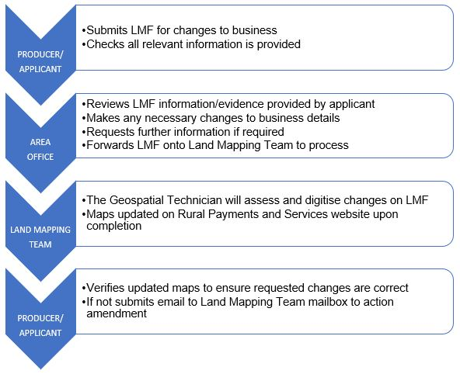
Figure 1

When does RPID reject an LMF?

Reasons can include:

- the LMF is not signed by the business representative,
- the LMF is not an original,
- you have not provided enough evidence,
- an appeal against a recent land inspection is underway,
- there has been no physical change to a feature on the ground and the change.

Map requirements for applicants

When submitting an LMF with land parcel changes, you should supply a map with the details of every change clearly shown. If you have an existing map, you must use it to notify changes. Do not use correction fluid when altering your boundaries. Mark crosses on the line to be altered and (clearly) make any amendments in ink other than blue, or yellow for maps with aerial photography as the backdrop.

If you have a new land parcel which has not been registered, draw the boundaries clearly on your existing map. Check if the previous owner/occupier has already received a new unique Land parcel identifier (LPID) and use this number. If the land parcel cannot be drawn on the map, supply another suitable map showing the land parcel.

The map should be an OS map (or a professional equivalent) at 1:2500 for land parcels up to 2000 hectares, and 1:10000 for land parcels greater than 2000 hectares. Make sure that the map sheet reference is marked on the map.

If you purchase or sell a land parcel which has already been registered you should enter the unique land parcel identifier on the LMF showing the type of change, date of change, area etc. You do not need to submit a map if the boundaries have not changed.

PDF copies of maps can be downloaded using Map Viewer or requested via the Land Mapping Team Mailbox: LandMappingTeam@gov.scot.

Rural Payments and Services Map Viewer and online LMF Submission

This is part of RPID’ s development of online services to make it easier to view up-to date business and map information. There is also the option rather than submitting an LMF via paper to make any required changes to your location code online.
To access your land information you need to log on to: Rural Payments and Services (Figure 2).

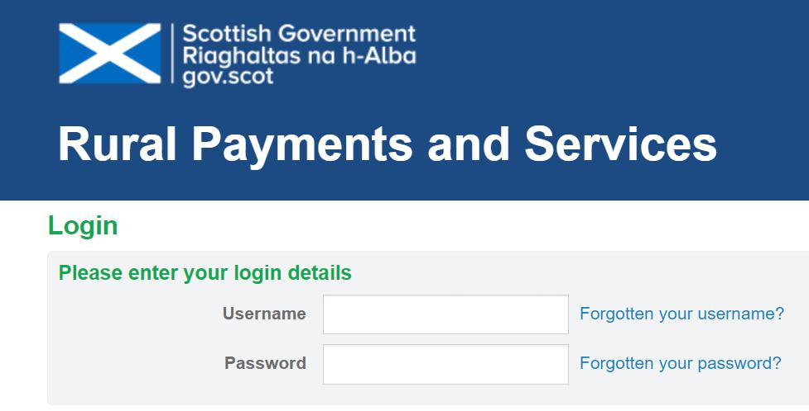
Figure 2

Once you have logged on you can select your business from your personal landing page. To access your maps you should the select the Business Name (Figure 3), followed by selecting the Locations Tab and then lastly click Map (Figure 4). This will now display your current maps in a separate tab.
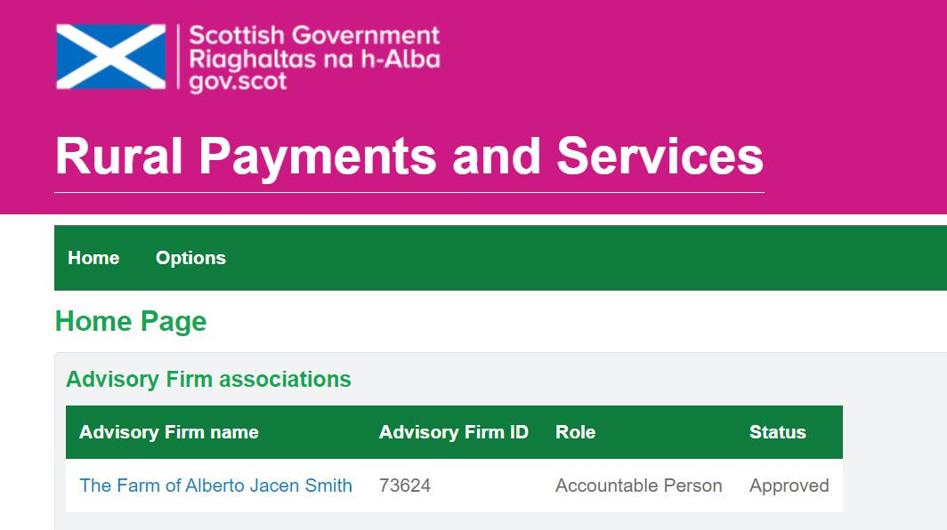
Figure 3

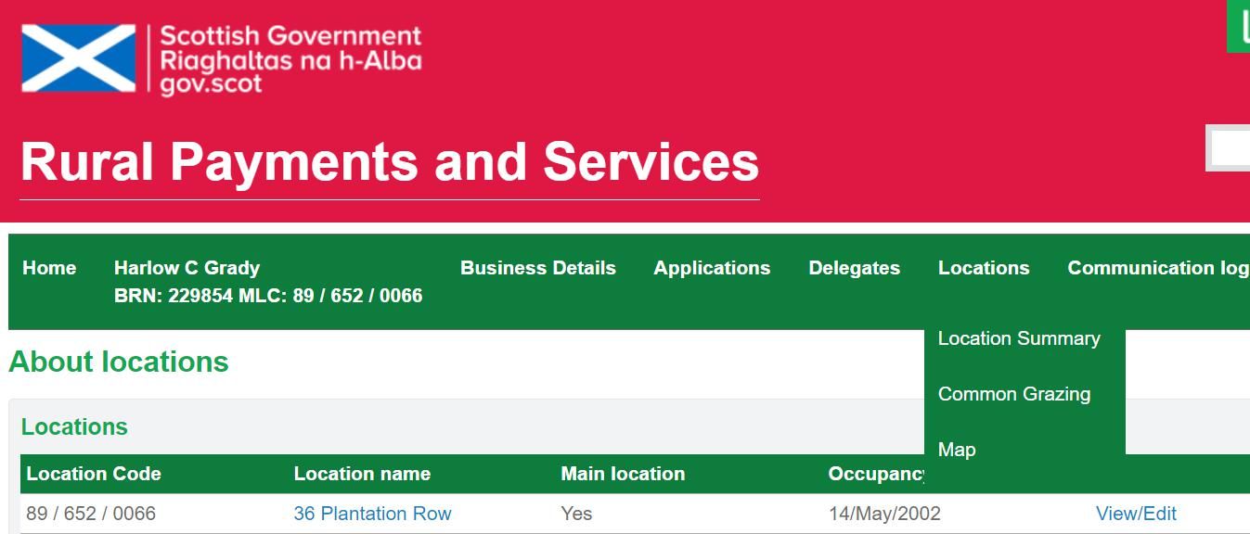
Figure 4

Guidance on how to navigate and use Map Viewer can be accessed using the link below: LPIS Guidance and Tutorial Videos

How to fill in your Land Maintenance Form

This is a step-by-step guide explaining how to submit your Land Maintenance Form and what information is required to make any relevant changes.

Part 1 – Applicant Details

The applicant must fill in Part 1 of the LMF. Complete the boxes with all the business details and contact information – BRN, business member/representative, contact number, email address, business address and main location code (Figure 5).

One of the tick box options must then be selected to indicate the type of land change that is required – Whole Location Code Transfer, Land Parcel(s) Transfer, New Land Parcel Registration, Removal of Land Parcel(s), Parcel Boundary Maintenance or Ineligible Feature Maintenance. More than one option can be selected if appropriate (Figure 5).

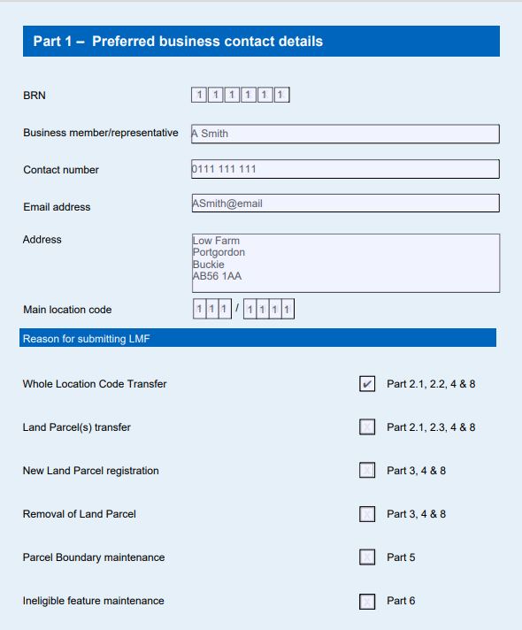
Figure 5

Each option has a section of the form relevant to each Land Change type, with the relevant part to be filled in as indicated. For Land Transfers, New Land Registration and Removal of Land Parcel(s), Part 8 should also be completed.

Part 2 – Transferring a Location Code/Land Parcels between permanent occupiers

If you require to transfer a whole location or individual land parcels to another business, please fill in Part 2. Part 2 contains the following:

- Part 2.1 - Applicant Details
- Part 2.2 – Whole Location Code Transfer
- Part 2.3 – Part of Location Code Transfer

Please Note: Any sale or transfer of land must have signatures of both incoming and outgoing parties (Part 8).

Part 2.1 – Applicant Details

Seller/Outgoing Tenant/Landlord

These details should be added if the applicant who is in receipt of the location code or land parcels has completed Part 1 (Form Submitter). BRN, business member/representative, contact number, email address and business address must be added. If this section has been completed by the Seller/Outgoing Tenant/Landlord, the tick box ‘Same as Part 1’ should be selected.

Purchaser/New Tenant/Landowner

These details should be added if the applicant who is granting the location code or land parcels has completed Part 1 (Form Submitter). BRN, business member/representative, contact number, email address and business address must be added If this section has been completed by the Purchaser/New Tenant/Landowner, the tick box ‘Same as Part 1’ should be selected (Figure 6).
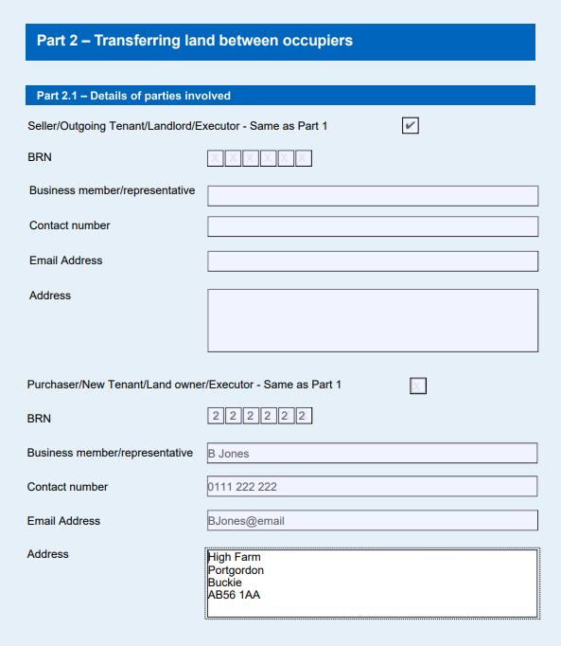
Figure 6

Part 2.2 – Whole Location Code Transfer

Complete this section if the whole location code is to be transferred. Please indicate, by selecting the tick box option, if you would like to transfer the whole location code. If yes, complete part 2.2 and do not complete part 2.3 (Figure 7).

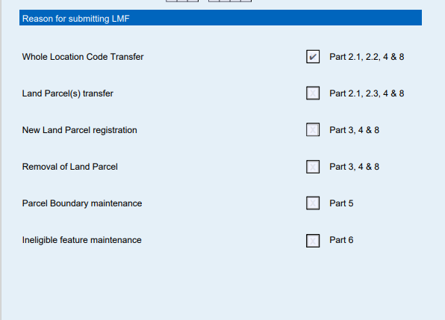
Figure 7
Additional information must be added for the transfer. A section is included in this part of the form for details of the whole location code to be transferred.

The date of transfer must also be added. An option must also be selected for Change Reason, either Sell/Buy, Move or Lease. Please select the appropriate option (Figure 8).

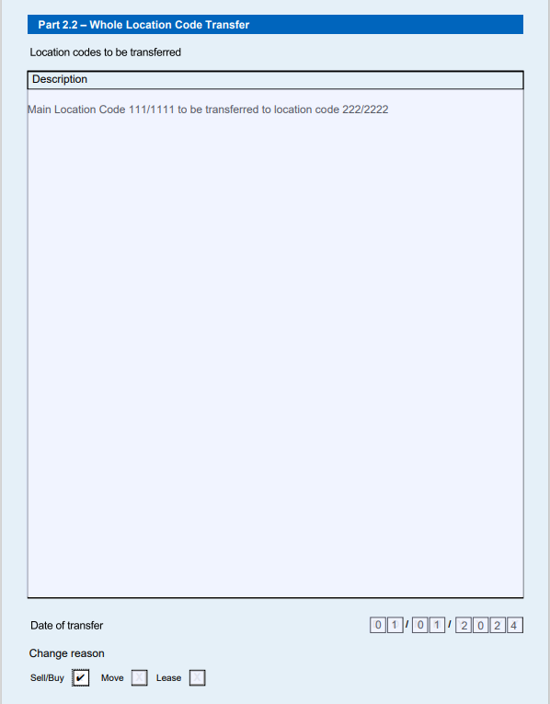
Figure 8

Part 2.3 – Part of Location Code transfer

Complete this section if only part of the location code is to be transferred. The land parcel identifier (LPID) for each parcel that is being transferred must be added, along with details of the location code it is to be moved from and the location code it is to be moved to.

The date that the LPID transfer is to take effect from must also be added, with a further tick box option where Sell/Buy, Move or Lease must be selected. If you require to move only part of a land parcel this must be indicated by selecting the relevant Yes/No tick box. A section is also provided where a description or any additional information can be added if required.

If you do require to move part of a parcel a map showing the part parcel to be moved/retained must be submitted. There is also a tick box where Yes or No must be selected to indicate if a map has or has not been submitted with the application.

Each LPID required to be moved should be added singularly. Multiple copies of this section can be submitted dependant on how many LPIDs you require to move (Figure 9). An extension page can be downloaded from the Rural Payments and Services website via this link – PF06 - Land maintenance form (ruralpayments.org)
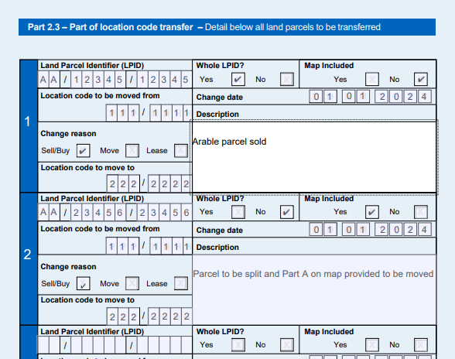
Figure 9

Part 3 – Register or Remove land parcels

Complete this section to register or remove land parcels by entering the (LPID), grid reference number, or use the code number of the unit to identify the land parcels. Please tick the box to indicate if you want to register or remove the LPID, and enter the change date, the location code and a description of the necessary change. A map indicating the area to be registered must be submitted with the LMF.

If you want to add a land parcel that has not been registered in the past (so does not have a unique LPID), you must register this area – provided it meets the mapping rules (the minimum size for a parcel is 0.1 ha). Documentation proving ownership must also be provided with a map that clearly displays the area to be registered.

Each LPID required to be registered/removed should be added singularly. Multiple copies of this section can be submitted dependant on how many LPIDs you require to register/remove. An extension page can be download from the Rural Payments and Services website via this link – PF06 - Land maintenance form (ruralpayments.org)

Register a new parcel

If you wish to add a land parcel (Figure 10) that has not been registered in the past (so does not have a unique LPID), you must register this area – provided it meets the mapping rules (the minimum size for a parcel is 0.1 ha).

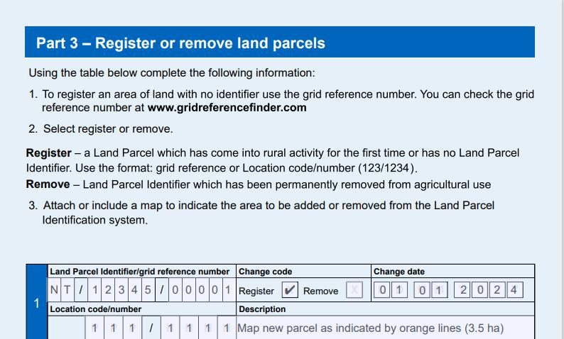
Figure 10

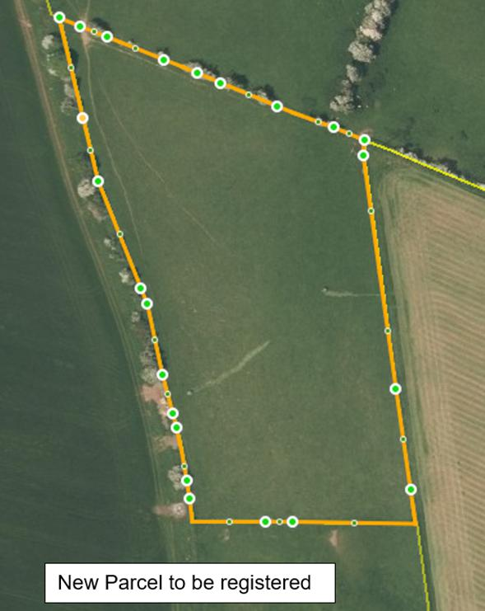
To do this you can use the Rural Payments and Services online mapping system or create the new field shape using a fine-tipped colour pen and the correct grid reference. Provide as much information as you can. If the parcel boundary is following OS lines please state this, If not please give measurements of the new boundary from a clearly defined point, such as a corner along an existing boundary and where it lies in relation to the other boundaries (Figure 11).

Figure 11

Removing a land parcel

If you want to remove a land parcel that is shown on your map, please fill in Part 3. A map can be provided if you wish (Figure 12).

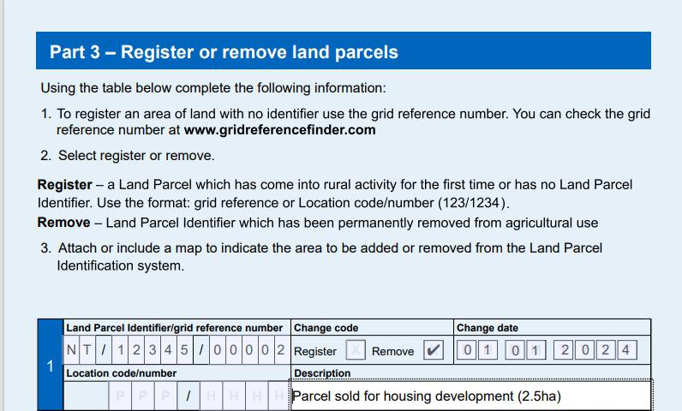
Figure 12

Part 4 – General Details of land to be transferred/registered

Complete the general details of the land that has to be transferred. Indicate the type of activity that will take place on that land and fill in the total area (owned and rented) of the location (Figure 13).

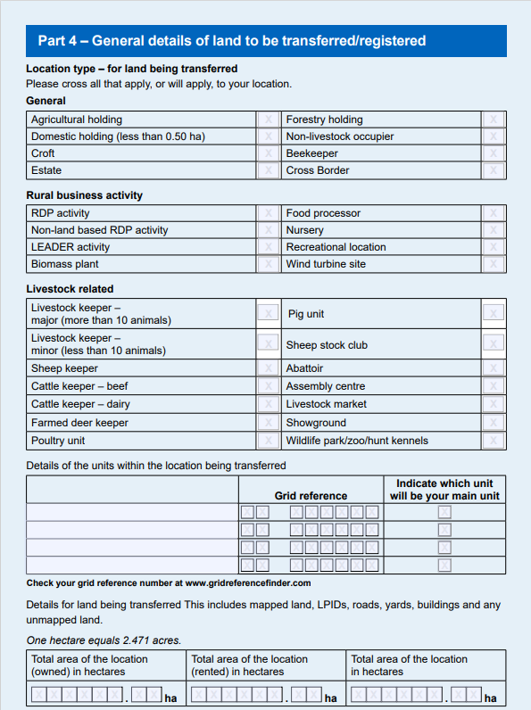
Figure 13

Part 5 – Land parcel boundary maintenance

Complete this section where land parcel boundary changes have taken place. The changes RPID can make to parcel boundaries and must be notified of are:
  - merge land parcels - where two or more parcels have merged on the same location
  - split land parcels – if the land parcel has been split into two or more land parcels
  - modify land parcel boundaries - to modify a land parcel boundary

For the purposes of the LMF, the Location Code must be added to the top of the page, also adding the LPID where the boundary is to be amended. You must then select either Merge, Split or Modify as an indication of the required change, with a change date added with relevant details of the change added to the Description box. A map clearly displaying the changes must also be provided.

Each LPID required to be amended should be added singularly. Multiple copies of this section can be submitted dependant on how many LPIDs you require to amend. An Extension Page can be downloaded from the Rural Payments and Services website via this link – PF06 - Land maintenance form (ruralpayments.org)

Examples of boundary changes
Merge – if two or more land parcels have merged on the same location
Split – if the land parcel has been split into two or more land parcels
Modify – to modify a land parcel boundary

Merging land parcels (Merge)

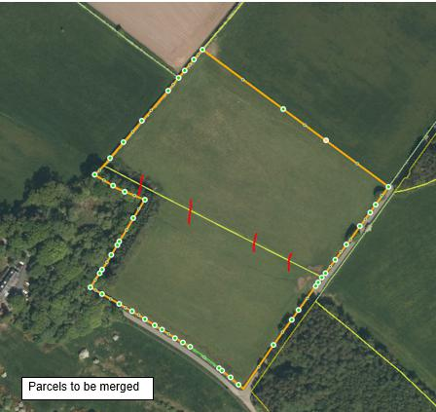
Use the Graphical Editor to mark the change as indicated (Figure 14) or you can cross through the line to be altered in ink on your IACS map. You can only merge land parcels when the boundary between the land parcels has been permanently removed – for example an old fence has been taken down.

Figure 14
Enter a LPID, the change date, tick the MERGE box and enter the LPID that it is merging with and any other additional information. Part 5 can be used if more space for information is required (Figure 15).

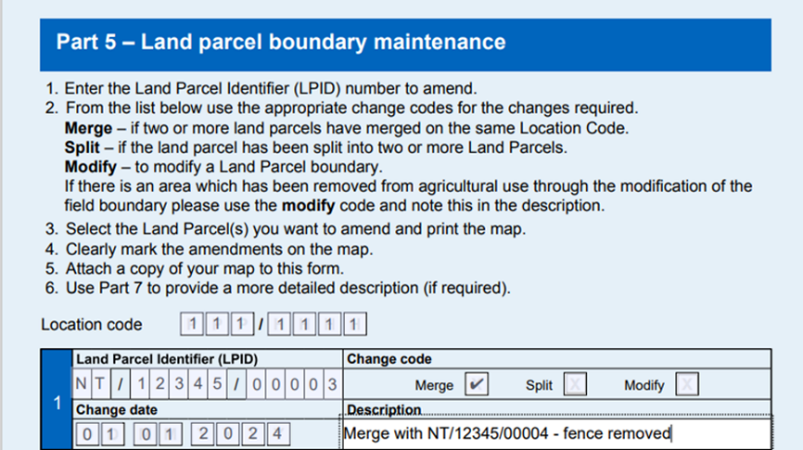
Figure 15

Splitting land parcels (Split)

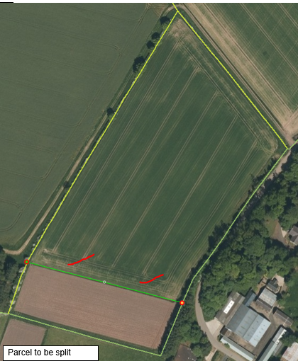
Use the Graphical Editor to mark the change as indicated, and create the new boundary or you can draw on the map with a fine-tipped coloured pen. If the new boundary is not indicated by an OS line, provide measurements of the new boundary from a clearly defined point, such as a corner along an existing field boundary and where it lies in relation to other boundaries (Figure 16, indicated by highlighted green line).

Please Note: Do not mark boundaries if the land parcel has been divided on a temporary basis.

Figure 16

Modifying a land parcel (Modify)

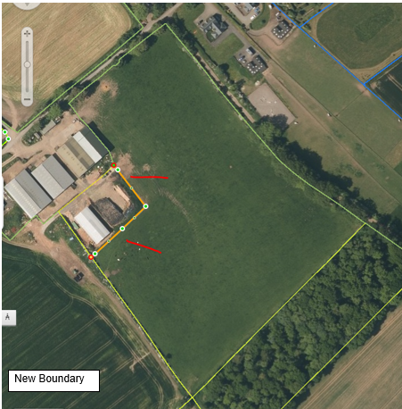
Use the Graphical Editor to mark the change as indicated and create the boundary change or modify the parcel boundary on the map using a fine-tipped coloured pen (Figure 17, outlined in orange). If the new boundary is not shown on the map that you are using, provide measurements of the new boundary from a clearly defined point, such as a corner along an existing field boundary and where it lies in relation to other boundaries.

Once a boundary has been amended, the area beyond must be considered. It will either be a new parcel (if it meets the mapping rules - Split), an amendment to the neighbouring parcel, or unregistered land (removed from the land owner /long term tenants map). Figure 17

In the example above (Figure 17), the area marked has to be removed from the field and unregistered land has been created for a new shed, the area is also fenced-off. Part 7 has been used for more information (Figures 18 & 19).

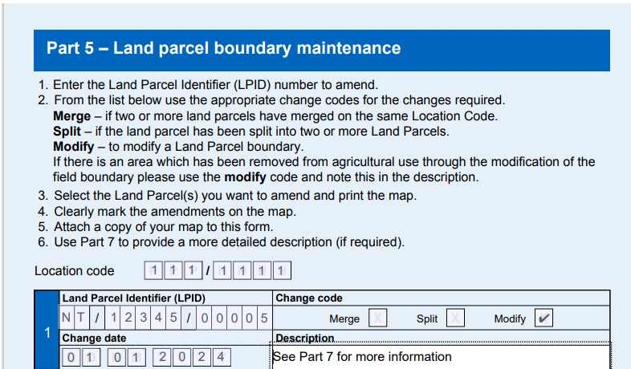
Figure 18

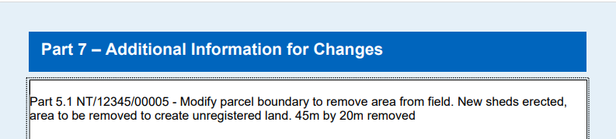
Figure 19

Part 6 – Ineligible features, amendments and maintenance

Complete this section where Ineligible Feature changes have taken place.

RPID is required to maintain an ineligible feature layer within the LPIS. We have identified ineligible soft and permanent features using OS, aerial photography, land review visits, and inspection data.

It is your responsibility to identify permanent physical features that are not eligible for payment within a parcel and notify RPID of the location and size by submitting a LMF. Changes that we must be informed of are:

- add or modify a BPS permanent ineligible feature
- remove a BPS permanent or soft ineligible feature
- increase a technically assessed band of a soft feature

For the purposes of the LMF the Location Code of the changes must be added to the the relevant box. Then a LPID, Feature ID and change date provided. One of the change reasons must then be selected, either New, Modify or Remove. Then a Feature Type, Area of coverage affected, and Ineligibility Banding must be added alongide a description of the change required. Where an Ineligible Feature is being added or modified, a map showing change must be provided.

Each LPID where a Ineligible Feature requires amendment should be added singularly. Multiple copies of this section can be submitted dependant on how many LPIDs you require to amend. An Extension Page can be download from the Rural Payments and Services website via this link – PF06 - Land maintenance form (ruralpayments.org)

What is a BPS permanent ineligible feature?

Detailed guidelines on how to assess features within a parcel boundary can be found
at: Rural Payments and Services: Assessing Eligible Land

For the purposes of completing the LMF, the 11 ineligible categories identified on the
LPIS have been split into two groups (Table 1): hard and soft ineligible features –

Table 1: List of hard and soft ineligible features
Ineligible Feature Category | Ineligilbe Feature Type | Ineligible Feature Code | Ineligible Feature Coverage Banding
Hard Features* | Water | WAT | Variable Coverage
Hard Features* | Road | ROAD | 100% Coverage
Hard Features* | Building | BUI | 100% Coverage
Hard Features* | Rocks | ROK | Variable Coverage
Hard Features* | Scree | SCE | Variable Coverage
Hard Features* | Foreshore | FSE | Variable Coverage
Soft Features*^{X} | Bracken | BRA | Variable Coverage
Soft Features*^{X} | Gorse | GOR | Variable Coverage
Soft Features*^{X} | Marsh | MAR | Variable Coverage
Soft Features*^{X} | Scrub | SCB | Variable Coverage
Soft Features*^{X} | Trees | TREE | Variable Coverage
* All permanent (hard) and temporary (soft) ineligible features greater than or equal to 0.01ha in area, must be marked on the map.

^{X} If a soft ineligible feature has increased in ineligibility, you may increase the size and technical assessment banding of the ineligible feature.

When amending an ineligible feature there is also set bandings that can be attributed to the ineligible feature in relation to coverage (Table 2).

Table 2: List of the Ineligible Feature Coverage Banding
Ineligibility Banding
<1%
1 – 3%
10 – 30%
30 – 50%
50 – 70%
70 – 90%
>90% (fully ineligible)

Both ineligible features for Road and Buildings will be set at 100% therefore the banding for these feature types do not have to be specified on the form.

Examples of ineligible feature amendments
When changing features there are three change codes that can be used:

New – use to add ineligible feature(s) that are within the parcel boundary
Modify – use for ineligible features that require to be amended in size within a parcel boundary or increasing a banding of technical assessment
Remove – use for ineligible features that have been completely removed from the parcel

These changes should be indicated on a map alongside the LMF.

Adding a permanent ineligible feature

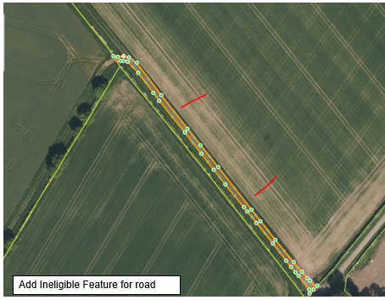
To identify a feature that is already mapped by OS and shown on aerial photography. Use the Graphical Editor to mark the ineligible feature or use a fine-tipped colour pen (Figure 20, outlined in orange).

Figure 20

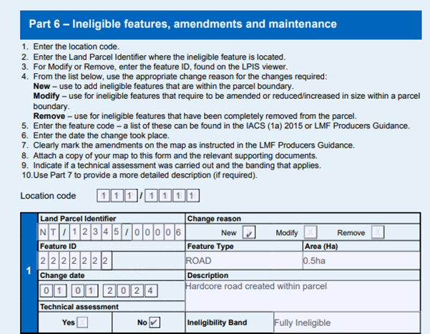Figure 21

Amending an ineligible feature

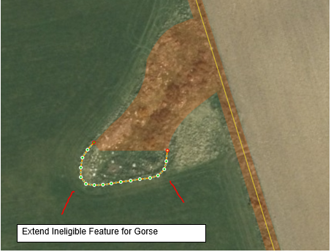
In this field, the landowner has indicated an extended area of growth within an area of gorse banded 40%. The landowner therefore has increased the size to reflect this adding to the area of ineligibility (Figure 22, outlined in orange).

Corresponding LMF Part 6 shown below (Figure 23).

Figure 22

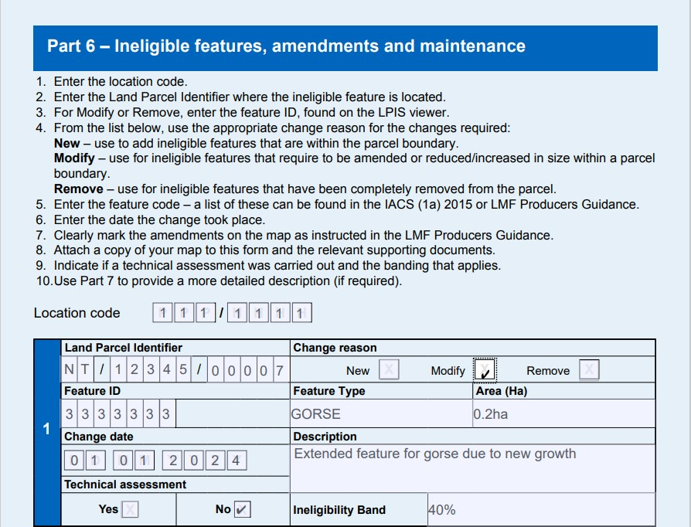
Figure 23

Removing a permanent ineligible feature

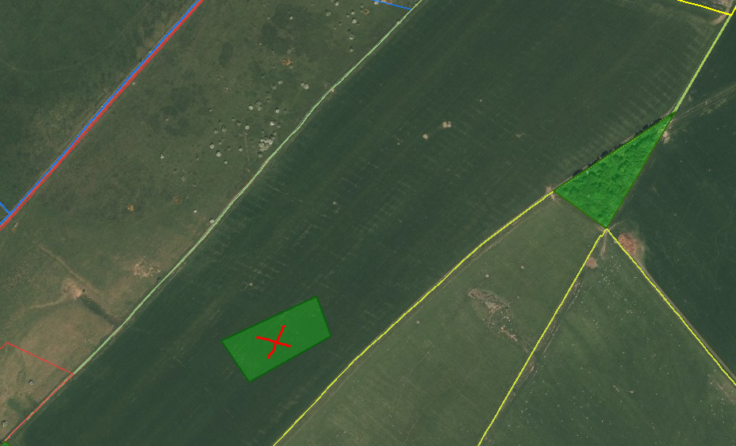
If you want to remove a BPS permanent ineligible feature that is shown on your maps, outline or put a cross through the ineligible feature (Figure 24) and record the size if known and a description of the change as indicated below. Evidence will need to be supplied such as photographs of the areas and/or contractor invoices.

Corresponding LMF Part 6 shown below (Figure 25).

Figure 24

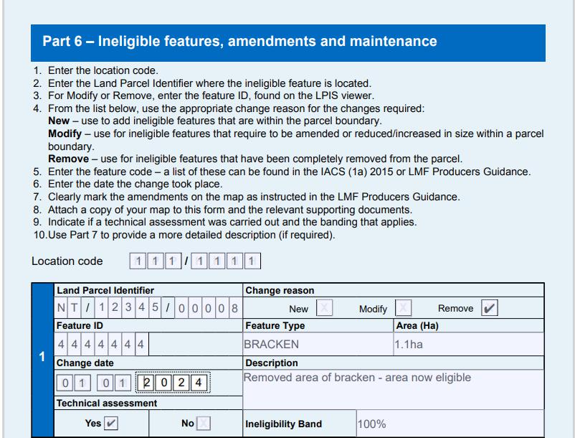
Figure 25

Adding a feature that is not mapped on OS or aerial photography

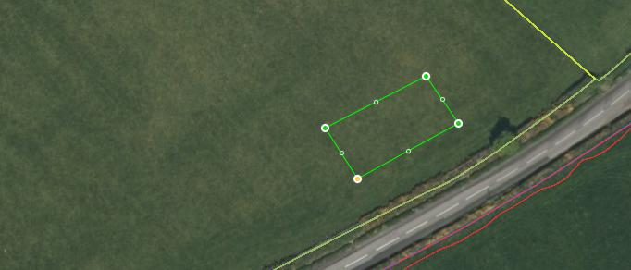
If the boundary of the BPS ineligible feature is not show on the IACS map or the OS map you are using, it would help us to measure the area correctly if you provide measurements of the feature and where it lies in relation to other boundaries from a clearly defined point – such as a corner (Figure 26).
Corresponding LMF Part 6 shown below (Figure 27). Figure 26

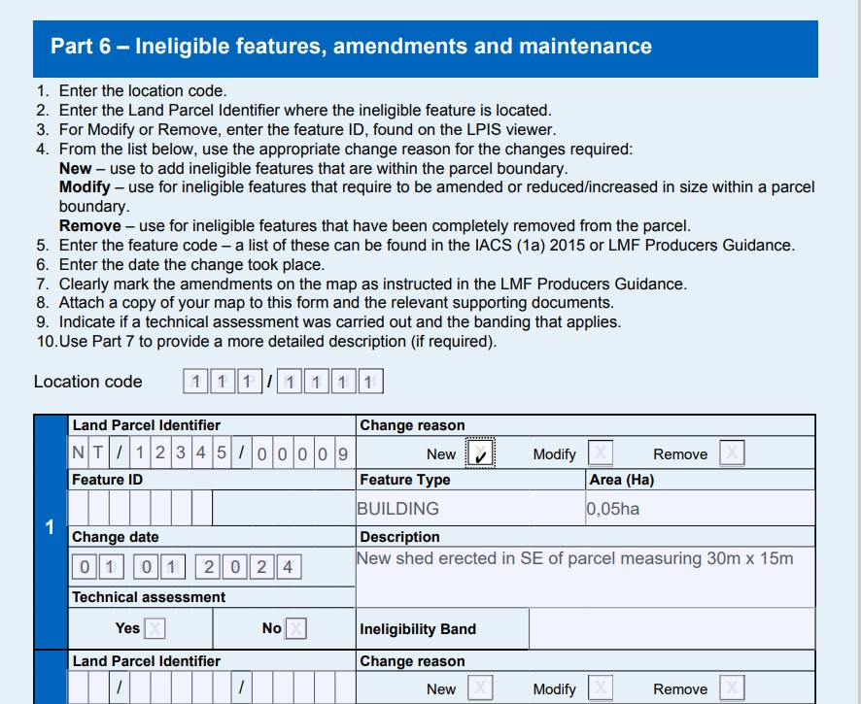Figure 27

Changing the technical assessment banding of soft feature

If you want to increase or decrease a soft features ineligibility banding, indicate the shape using a reference number, use OS or draw around the features shape indicating the size and technical assessment banding the feature should be.

Previously, this landowner identified the area covered (Figure 28, 0.1ha outlined in orange) and assessed it within the technical assessment banding 30 – 50%.
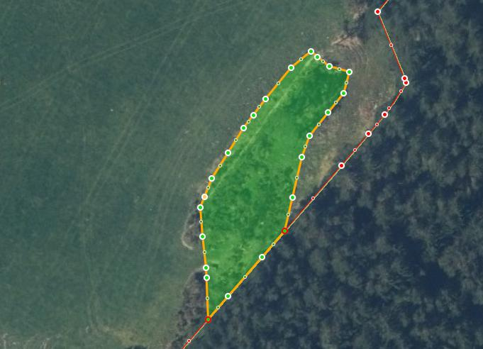
Figure 28

Corresponding LMF Part 6 shown on following page (Figure 29).

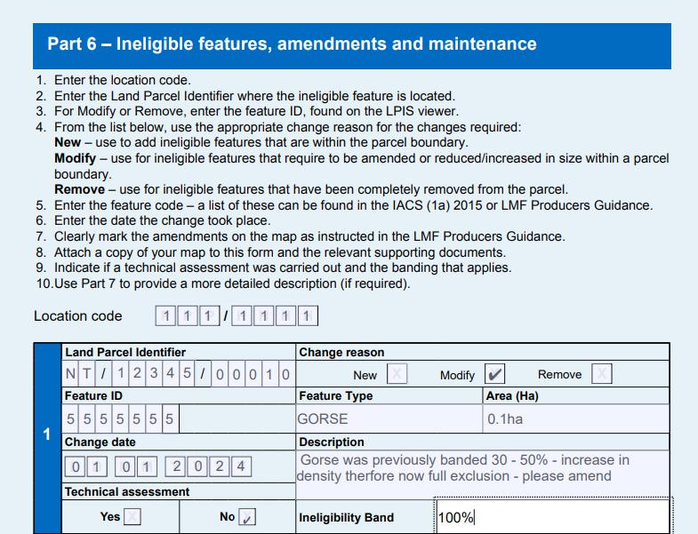
Figure 29

Part 7 – Additional information for changes

Use this section to provide any additional information which might be helpful in processing the LMF form (Figure 30).

If you do not provide enough information this will hold up your LMF and the changes requested, which may result in a delay of any payment(s).

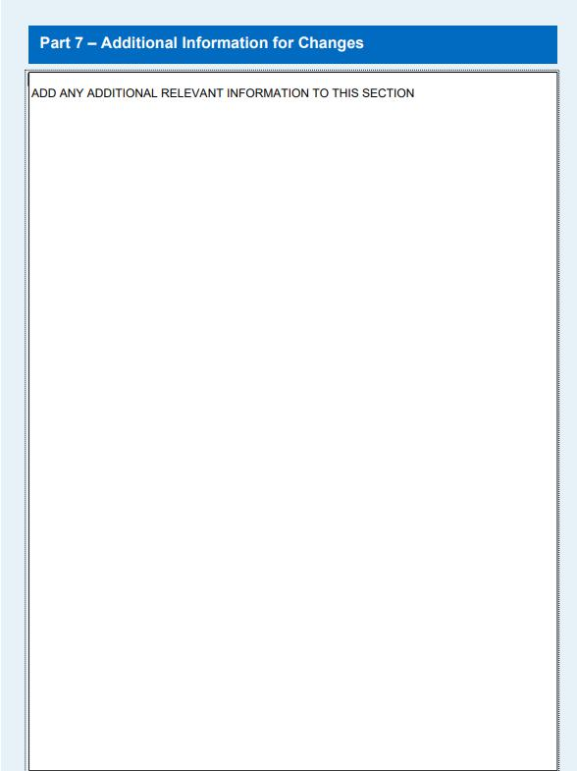
Figure 30

Part 8 – Confirmation from outgoing and incoming occupiers

Where there has been a transfer of land, in all instances the signatures of both the incoming and outgoing parties must be added to the form (Figure 31). If this information is not fully submitted this will hold up your LMF and the requested transfer, which may result in a delay of any payment(s).

Where the contact number and email address have been provided on Part 2.1 these do not require to be added.

If the changes are being instructed through an Agent their unique Business Advisory Firm ID number must be added.

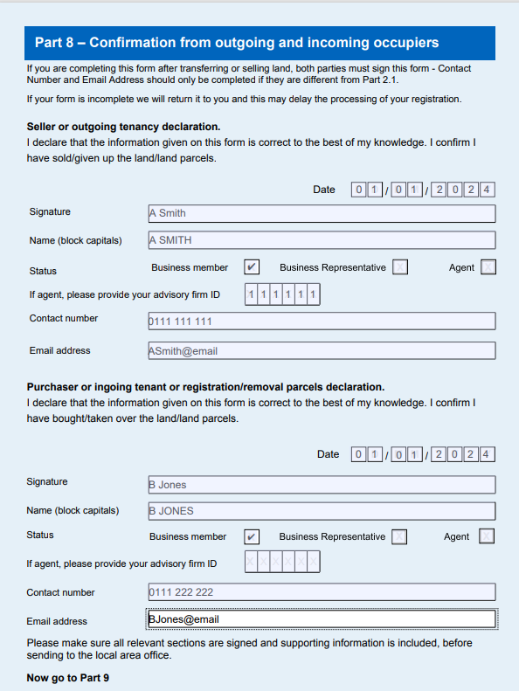
Figure 31

Part 9 – Declaration

The declaration must be signed (Figure 32) by an authorised signatory of the business (Business Member, Business Representative or an authorised signatory of a Mandated Agent).

There is also an option in Part 9 to add details of any documents that have been included in the submission. The number of documents submitted should be added with a list of any documentation included within the box provided.

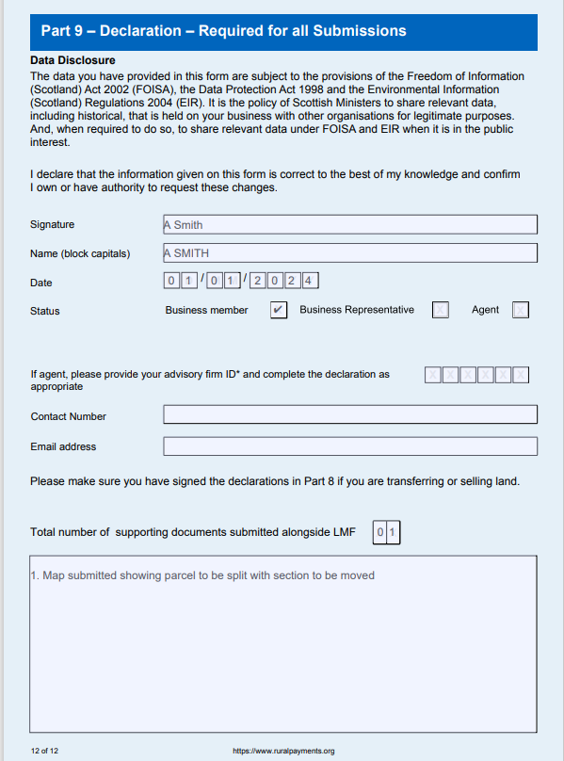
Figure 32

Supporting Documents

In some cases supporting documents must be submitted with your LMF form. Types of supporting documents we may require, include:

- IACS Maps
- Ordnance Survey maps
- professionally drawn maps
- photographs
- contractor evidence (in the case of removing a soft feature)

If you are sending supporting documents, write your Location Code and/or BRN on them clearly. We will do our best to return these documents to you, however we strongly recommend you keep a copy of your LMF for reference, as well as copies of any supporting documents.

Please Note: If you have followed the steps to remove an ineligible feature from your parcel, you will be required to submit photographs of the area in question as evidence. The pictures must be meaningful (such as a panoramic view from a specific reference point that can be identified from aerial photography – like a gateway or telegraph pole).

How to estimate a land parcel reference number

When you look for a place on a map you use grid lines, a system of vertical and horizontal lines which divide the OS map into squares. The vertical lines are called eastings because they run west to east (left to right) and the horizontal lines are called northings because they run south to north (bottom to top).

Great Britain is split into 100 x 100 kilometre grid squares (Figure 33). Two letters (for our example below we used NT), identify each of these grid squares. These letters form the first part of any grid reference – so the map reader can easily find the relevant square the grid reference relates to.

Each 100 x 100 kilometre grid square is covered by grid lines spaced 1 kilometre apart. The horizontal lines are called Northings and vertical lines are called Eastings (Figure 34). They have reference numbers and form the second part of a grid reference, for example the reference is 646504. To complete the reference, you need the two letters which you identified from the above map of the UK .
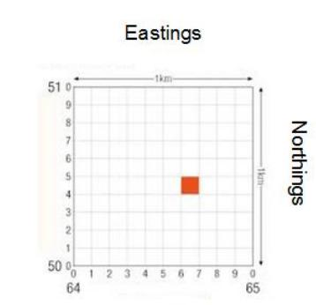
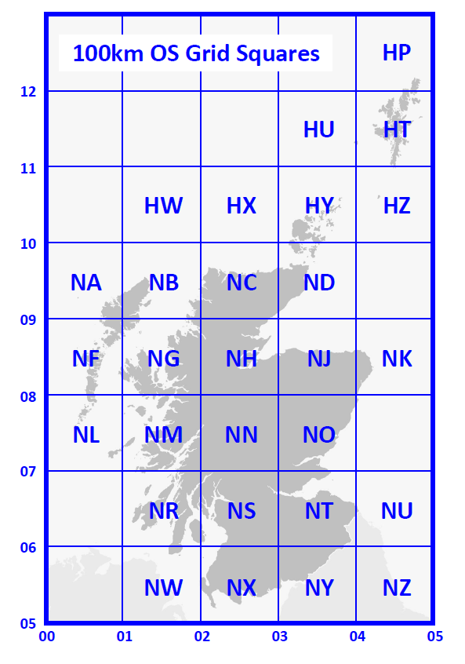

Figure 33 Figure 34

