

Sheep & Goat Traceability
The 5-Mile Concession rule Q&A
Q1. What does the concession mean for a keeper?
A: The concession allows keepers to move sheep and goats between temporary or seasonal grazing land within 5 miles of any permanent location (Main location code or a permanently held sub location) held by the business without needing to:
- record the movement in their holding register
- notify the Scottish Animal Movement Unit (SAMU) by completing a movement document
- apply baseline or movement tags because of the move
Each location has a County Parish Holding (CPH) number in the format of 11/222/3333.
Full guidance on livestock identification and traceability, including the 5-mile concession, is available at Gov.scot under Livestock.

QR Code 1 – Sheep & Goat keeper guidance on -Scottish Government website

Q2. Is there anything I need to do if I use the concession?
A: Yes. You must:
- notify your local Animal Plant Health (APHA) office of all seasonal and temporary CPHs that you keep animals on
- notify APHA within 30 days of any changes
- apply tags to lambs and kids at the required age
- record the CPH of the land you are using and the dates which you had occupancy of the land. This information can be recorded on the inside cover of the holding register, for example:

Seasonal Grazing Arrangement
Location Code: 88/111/0001
Grazing Period: From 26th November 2025 to 1st April 2026

Q3. What land does the concession cover?
A: The concession could apply to temporary or seasonal grazing land that is within 5 miles of a permanent location held by your business.
By this we mean, land which is within 5 miles but that you cannot amalgamate under Rural Payments and Inspections Division (RPID) business rules.

Q4. Can I use the concession for permanently farmed land within 5 miles of my main holding?
A: No, however you may be able to amalgamate this land under your main CPH.
Note: rules on amalgamating holdings considers many different factors including distance between locations. Your local RPID office can provide more information if required.

Q5. Can I use this concession if my stock will be mixing with another keepers stock on a holding?
A: No. The concession is intended solely for land under your temporary occupancy. If animals (including other species) belonging to different keepers are to be in the same field you cannot use this concession.

Q6. For animals born on concession land, which holding should be used for the baseline tag when lambs or kids leave or reach tagging age?
A: Use the flock mark allocated to your permanent land CPH to which the concession is being utilised from.

Q7. How is the 5 miles measured?
A: The 5 mile distance is measured from the boundary of your permanent land. 5 miles is equal to 8.04 km.
Any temporary or seasonal land which has a boundary within 5 miles can be considered under the concession rules.

Q8. What will happen during an inspection?
A: During an inspection, RPID inspectors will check:
- that CPHs used under the concession are within 5 miles of the boundary of your permanent land CPH
- that you are registered with APHA on all CPHs used to keep sheep and/or goats
- that you have recorded the CPHs and the dates of occupancy in your holding register
Sheep and goats found on land not eligible for the 5-mile concession will be subject to standard identification and traceability rules.
Where non-compliance is identified, enforcement action may be taken under The Sheep and Goats (Records, Identification and Movement) (Scotland) Order 2009.
If you receive support payments, breaches may also result in penalties under Cross Compliance rules, specifically Statutory Management Requirement (SMR) 8.
Further guidance on what to expect during a sheep and goat inspection is available at www.ruralpayments.org under livestock inspection

QR Code 2 – Sheep & Goat inspection information on RP&S
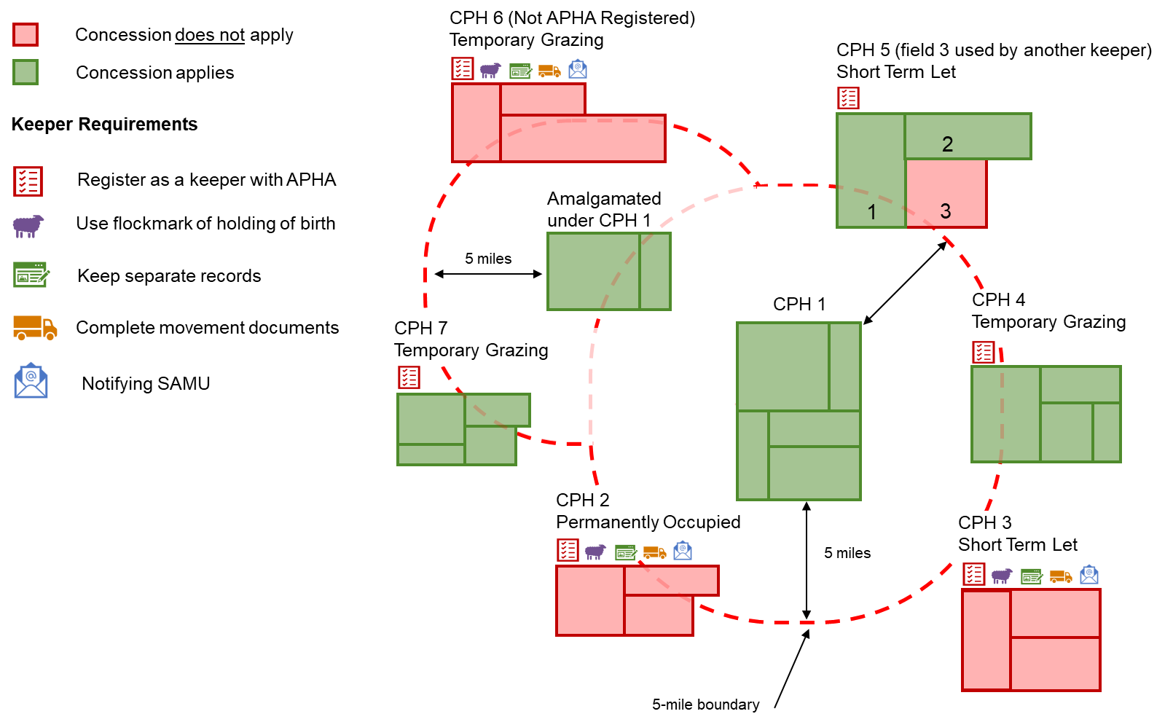
Notes:

CPH 2 Concession cannot be used because it’s a permanently occupied piece of land.

CPH 5 Fields used by another keeper cannot be used under the concession. Fields 1 and 2 can be used.

CPH 6 & 7 Both CPHs are temporary grazings within 5 miles of the main CPH (including amalgamated land). However, the concession cannot be used for CPH 6, as it is not registered with APHA.

In Scotland, this is usually within 9 months of birth. If reared indoors this is reduced to 6 months.
In Scotland, this is usually within 9 months of birth. If reared indoors this is reduced to 6 months.

